UNDP INDONESIA - PROJECT ASSURANCE REPORT (PAR) 2022

Reporting Period: ☒ 1st semester (January-June) ☐ 2nd semester (January up to expected progress by December)

IATI PROJECT INFORMATION – COUNTRY PROGRAMME AND STRATEGIC PLAN LINKING
Project Award ID & Title | 00127239 GEF Capacity Building Initiative for Transparency (CBIT) Indonesia  SELECT PROJECT ID AND PROJECT NAME
CPD Outcome | New CPD Outcome 3. Institutions, communities and people actively apply and implement low carbon development, sustainable natural resources management, and disaster resilience approaches that are all gender sensitive
Project Output ID(s) | Output ID | Output Description |  | Gender & COVID-19 Markers |  |  | UNSDCF, UNDP Strategic Plan, and UNDP CPD Outputs Linkage
00121155 | 00121155  CBIT Indonesia | This Project aims to strengthen Indonesia’s technical and institutional capacity, to meet the Paris Agreement on Climate Change Enhanced Transparancy Framework (ETF) requirements when implementing priority actions for achieving its nationally Determined Contribution (NDC) and its goals related to low carbon emission development and climate resilience. |  | GEN 2: Promotes GE significantly  Select COVID-19 Marker |  |  | New CPD Output 2.3. Low emission and climate-resilient objectives addressed in development plans and policies to promote economic diversification and green growth (Strategic Plan Output 2.1.1)  Select Relevant UNSDCF 2021-2025 Output  Select Relevant UNDP Strategic Plan 2022-2025 Output
 |  |  |  | Select Gender Marker  Select COVID-19 Marker |  |  | Select Relevant UNDP CPD 2021-2025 Output  Select Relevant UNSDCF 2021-2025 Output  Select Relevant UNDP Strategic Plan 2022-2025 Output
 |  |  |  | Select Gender Marker  Select COVID-19 Marker |  |  | Select Relevant UNDP CPD 2021-2025 Output  Select Relevant UNSDCF 2021-2025 Output  Select Relevant UNDP Strategic Plan 2022-2025 Output
 |  |  |  | Select Gender Marker  Select COVID-19 Marker |  |  | Select Relevant UNDP CPD 2021-2025 Output  Select Relevant UNSDCF 2021-2025 Output  Select Relevant UNDP Strategic Plan 2022-2025 Output
Project Duration | From 01/01/2022 to 31/12/2025.
Implementing Partner: | Ministry of Environment and Forestry (KLHK) - NIM, Unit/Directorate: IGRK & MRV
Project Board Members: | - Ministry of Maritime & Invesment Affairs  - Ministry of National Development Planning / BAPPENAS  - Ministry of Energy and Mineral Resources  - Ministry of Transportation  - Ministry of Industry  - Coordinating Ministry for Economic Affairs  - Ministry of Public Works and Public Housing  - Ministry of Agriculture  - Ministry of Finance  - Ministry of Women’s Empowerment and Chilf Protection
Project Focal Points | Programme Manager : Anton Sri Probiyantono, Senior Programme Manager, Environment Unit, anton.probiyantono@undp.org +62(0) 811 9203 435  National Project Director : Dr. Ir. Syaiful Anwar, M.Sc., IPU, Director IGRK & MRV, syaifula09@gmail.com, +62(0) 811 900 316  Project Manager/Coordinator : Dra. Endang Pratiwi., M.M, National Project Managemenet, e.pratiwi63@gmail.com, +62(0) 811 113 266  M&R Focal Point : <Name>, <Designation/Title>, <email address>, <mobile/WhasApp No.>
Project Markers: | 1. Human Rights Elements (UN INFO):
 | - Is there a reference in the prodoc/AWP to particular efforts made by project for the promotion of enjoyment or fulfillment of human right/s, such as addressing discrimination, in project’s activity? |  |  |  | YES. Reference in Prodoc/AWP is available, to suport efforts the promotion of enjoyment of human rights
 | - Is there an explicit reference in the prodoc/AWP to human rights standards/conventions/treaties or the outcomes from human rights mechanisms in the activity description? |  |  |  | NO. Need to be improved.
 | - Is there a specific aim and/or strategies at addressing issues of discrimination, inequality or marginalization in the prodoc/AWP? |  |  |  | NO. Need to be improved.
 | - Is there a specific reference in the prodoc/AWP about the engagement of "right holders" (beneficiaries/individuals that can make legitimate claims) and "duty bearers" (primarily state actors)? |  |  |  | YES. Prodoc/AWP has reservation on the engagement Duty Bearers and Rights Holders
 | - Are the affected groups/organization (i.e. beneficiaries/rights-holders) engaged in a meaningful way? |  |  |  | YES. Participation and meaningful engagement of beneficiaries and/or rights holders incorporated in project activities
 | - Is there a thorough human right analysis, such as a gender, and/or social inclusion analysis report conducted to inform project implementation? |  |  |  | YES. Project conducts a thorough human rights analysis , disagregated by gender and other elements of Social inclusion
 | Human Rights Marker: |  |  |  | HR 2: Significant contribution to realization of human rights (3-4 of the 6 HR Marker Elements are identified).
 | 2. Hows (select up to 3 items): |  | ☒ Capacity Development / Technical Assistance |  |  | ☒ Data Collection and Analysis |  | ☒ Institutional Mechanism and System Building
 | Types of innovative approach (if applicable): |  | ☐ Select innovation type  ☐ Select innovation type
 | 3: Whos (Select maximum 5 items):
 | Geographic:  ☒ People living in urban areas  ☒ People living in rural areas |  | Shocks and fragility:  ☐ Select relevant target  ☐ Select relevant target |  |  | Socio Economic  ☐ Select relevant target  ☐ Select relevant target |  | Status (PwD, youth, etc.):  ☐ Select relevant target  ☐ Select relevant target
 | Specify the location: Indonesia
 | 4. Partners (select up to 5 items): |  | ☒ National government  ☒ Donor government |  |  | ☒ Sub-national Government  ☒ NGOs/CSOs |  | ☒ Research Institutions/Universities
 | 5. Joint Programme (select only 1 item): ☒ Joint Activity
 | 6. SSTC (select only 1 item): ☒ Partnership facilitator
 | 7. Humanitarian (select only 1 item): ☐ Select humanitarian type

RESULTS AND BUDGET DELIVERY

  - Project Activity Results
Project Outputs  (based on AWP) | Key activities (including gender related) undertaken during the reporting period  (Elaborate the objective and results achieved, date, location, participant/beneficiaries disaggregated by gender, youth group, persons with disability-PwD, marginalized group, etc.) | Data on beneficiaries  (No. of beneficiaries by gender, youth group, PwD, marginalized group, etc.)
Component 1: Institutional Capacity Strengthening for Climate Transparency.  Outcome 1.1 : Strengthened Institutional Arrangement for Climate Transparency  Output 1.1.1 : Institutional climate transparency mechanishm / unit established | Activity Result 1.1.1.1 : Publication and Engagement of parliament, non-party stakeholder (NPS), youth & Gender and commitment of related government/institution entities in delivering CBIT activities to the grass root levels  Activity 1,1,1,1(a): Preparation of Inception Meeting, Engagement of parliament, non-party stakeholders (NPS), youth & gender and commitment of related government/institution entities in delivering CBIT activities to the grass root levels.  Organized a series of coordination meetings to bring stakeholders to build a shared understanding of the CBIT initiative and project implementation from 09 May to 11 May 2022. One of the meeting held an Inception Workshop. The meeting to inform stakeholders about the goals and objectives of the CBIT activities and to, review and validate the project result in the framework; building a shared understanding of strengthening institutional capacity; Disseminating the CBIT work program to stakeholder; Finalizing the preparation of the project’s first Annual Work Plan (AWP) based on the project’s Results Framework; Discussing the project organization structure and roles and responsibllities (including monitoring and evaluation) of the project team and UNDP and stakeholder engagement strategies  Activity Results 1.1.2.2: Supporting national MRV system  Activity 1.1.2.2 : This activity will involve the design and conduct of capacity building for mitigation action verification on the certification  Technical guidance activities to increase human resource capacity in the industrial sector to support efforts to achieve the NDC (Nationally Determined Contributions) Target in the Transparency Framework carried out on 23 - 24 June 2022. this activity is a collaboration between the Ministry of Environment and Forestry and the ministry of industry, which aims to increase the capacity of the Technical Implementation Unit under the guidance of the Ministry of Industry in carrying out measurement and reporting of GHG emissions from industrial activities to support efforts to achieve the contribution target to NDC (Nationally Determined Contributions) in the framework of transparency. This activity will indirectly support and stimulate the implementation of Carbon Economic Value (NEK) in the industrial sector. The activities carried out in hybrid (online & offline) were attended by eleven Industrial Centers and thirteen Industrial Standards and Services Centers  Link to Activity 1 ID 00127239 (AWP) | Activity 1.1.1.1(a)  Beneficieries:  - Fifty-four participants from 27 institutions attended the coordination meeting, with 48% women.  Activity 1.1.2.2  Beneficiaries:  Thirty participants from 25 institutions attended the technical guidance, with 50% women.
Component 1: Institutional Capacity Strengthening for Climate Transparency.  Outcome 1.2 : Capacitated government and non-party stakeholder to establish the long-term strategy and access to financial resources, capacity building, and technology transfer  Output 1,2,1 : Gap analysis on Gender Equality conducted | Activity Result 1.2.1.1 : Baseline on gender equality.  Activity 1,2.1.1: in the first year, this activity will organize a series of stakeholders’ consultation meeting to determine the essential aspects for designing baseline study.  Focus Group Discussion (FGD) on gender mainstreaminh in climate change was held on June 16,2022. This activity aims to conduct a basic assessment of regulations and gender analysis as material for making a baseline on gender equality. This activity was attended by gender experts and antrppologies from UNPAD, CS’S, and UNPAD postgraduate students. Before the Gender FGD, on 15 June 2022, we also carried out a campaign with the Theme ‘Youth and Business on Climate Change”  Link to Activity 1 ID 00127239 (AWP) | Activity 1.2.1.1  Beneficiaries:  This activity was attended by 30 participants offline and 15 online, with 85% attending by women
Component 2: The Development and Establishment of Robust Systems for GHG Inventory, and Measurement, Reporting, and Verification (MRV) emiision in compliance with the Paris Agreement  Outcome 2.1.: Enhanced Quality Assurance (QA)/Quality Control (QC) and verification process as well as adoption of improvement plans  Output 2.1.1: GHG Inventory reviews conducted to validate approaches and results | Activity Result 2.1.1.1 Mapping current activity data of GHG inventory at regional/sub-national level and identifying targeted sectors.  Activity 2.1.1.1(a): This activity involves FGD, working groups or in-dept discussion  The SIGN_SMART ToT activity was conducted on 10-11 May 2022. This activity aims to increase the capacity of human resources at the sub-national level. This activity was attended by officialas and staf from the Directorat of Greenhouse Gas Inventory and MRV, Balai PPIKHL, UPT with the sope of the Ministry of Environment and Forestry, SKPD within the Province of Bali, and Academics.  Activity 2.1.1.1(b): This activity involves FGD, working groups or in-dept discussion  The FGD on Capacity Building for Monitoring, Reporting, and Verification (MRV) of climate change adaptation actions were carried out on 23 June 2022. The purpose of this activity is 1. Conduct a brief review of climate change adaptation actions listed in SRN 2. Discuss the MRV framework for climate change adaptation after the issuance of Presidential Decree 98/2021; the participants of the activity were attended by the Secretariat of the Directorate General of Climate Change Control, the Directorate of IGRK & MPV, the Directorate of Adaptation, the Directorate of Mitigation, the Directorate of Sectoral Resource Mobilization, and the Directorate of Forest and Land Fire Control of the Ministry of Environment and Forestry.  Link to Activity 2 ID 00127239 (AWP) | Activity 2.1.1.1(a)  Benficiaries:  - 40 participants with 40% women, attended this activity  Activity 2.1.1.1(a)  Benficiaries:  29 participants with 40% women, attended this activity
Component 2: The Development and Establishment of Robust Systems for GHG Inventory, and Measurement, Reporting, and Verification (MRV) emiision in compliance with the Paris Agreement  Outcome 2.2: Strengthened domestic MRV System  Output 2.2.1 : Sectoral interfaces for domestic MRV system and improved data collection design engineered | Activity Results 2.2.1.1 : Review National Registry System (NRS) for adaptation scheme  Activity 2.2.1.1(a): This activity involves the prevision of technical support in reviewing framework and mechanism for adaptation scheme in the national registry system  Techincal guidance activities for ProKlim registration data filling for Social Frestry assistants in Central Kalimantan Province are carried out in two stages; (a) on June 14,2022, a technical guidance preparation activity will be carried out through the Zoom Cloud Meeting Application in Central Kalimantan; (b) The practice of registering ProKlim locations into SRN and filling in data into SPECTRUM is carried out for three days on 28-30 June 2022. The purpose of this activity is to record the location of the climate village.  Activity 2.2.1.1(b): This activity involves the prevision of technical support in reviewing framework and mechanism for adaptation scheme in the national registry system  The FGD activity to increase the emission reduction capacity of the agricultural sector in meeting indonesia’s NDC targets within the transparency framework was carried out on June 30, 2022. This activity aims to increase stakeholders’ understanding and capacity within the West Java Province government regarding mitigation effort in the Agricultural sector to strengthen tecjnical capacity and Indonesia institutions in low emission development.  Activity Results 2.2.1.4 : Enrichment by identification reduction emission methodology  Activity 2.2.1.4 : This activity will consist on the development of MRV methodolpgy team panel  The FGD on Capacity Building for Reducing Emissions in the Agriculture Sector in meeting Indonesia's NDC targets in the transparency framework was held on June 30, 2022. The purpose of this activity is • capacity building of stakeholders within the West Java provincial government regarding mitigation efforts in the agricultural sector to strengthen Indonesia's technical and institutional capacity in low emission development. • Equalization of perceptions to achieve the target contribution of the Indonesian NDC agricultural sector by 2030 and net zero emissions by 2060 • Submission of the principle of transparency in emission reduction data collection through the SRN platform activity participants from the Environmental Service of West Java Province; Department of Food Crops and Horticulture of West Java Province; Department of Food Security and Livestock West Java, West Java Provincial Plantation Service, Vegetable Crops Research Institute, Lembang, West Java, Ornamental Plant Research Institute, Cianjur, West Java, West Java Agricultural Training Center, West Java Province Food Crops Agriculture Service, Faculty of Agriculture, Padjadjaran University  Activity Results 2.2.1.8: Guidelines on monitoring, reporting and verification for adaptation action  Activity 2.2.1.8 : This activity will focus on development guideline on monitoring, reporting, and verification for adaptation action  Organized technical guidance and refresher ProKlim verification for two days on 17-18 May 2022. The purpose of this activity is to provide an understanding of the technical procedures for implementing Pro-Klim verification in the field and provide an understanding of procedures for filling and verifying SPECTRUM data in the field, as well as increasing the capacity and capability ProKlim verifier of the Ministry of Environment and Forestry. The participants of this activity came from the Center for Climate Control and forest and land fires in 5 regions in Indonesia, the Directorate of Adaptation, the Directorate of Mitigation, and the Directorate of PKHL.  Link to Activity 2 ID 00127239 (AWP) | Acitivity 2.2.1.1(a)  Beneficiaries:  50 participants attended this technical guidance activity. This includes female representative. However, there is no gender ratio data for this meeting.  Activity 2.2.1.1(b)  Beneficiaries:  This activity was attended by 27 participants attending offline and 7 online with 50% women.  Activity 2.2.1.4  Beneficiaries :  35 participants with 45% women, attended this activity  Activity 2.2.1.8  Beneficieries:  The activities were carried out online and offline, with a total attendance of 65 participants (35 offline and 30 online). This include female representative. However, there is no gender ratio data for this meeting.
Component 3 : Strengthened National Determine Contribution (NDC) Implementation and tracking progress  Outcome 3.1 : Progress tracking tool on NDC and transparency in place  Output 3.1.1 : Review of information provided in the NDC undertaken, including the quality of baseline projections | Activity Result 3.1.1.1 : Implementation of Roadmap NDC Mitigation in each sector: energy (and transport), forestry, agriculture, waste, industrial process & product use (IPPU), and mappin of NPS contribution  Activity 3.1.1.1 : This Activity will involve supporting the development of NDC roadmap implementation for energy (and transport), forestry, agriculture, waste, industrial process & product use (IPPU) sectors, and benchmaking baseline in kabupaten/kota governments.  SPECTRUM technical guidance activities were combined with technical guidance and refresher activities for PROKLIM verification (output 2.2.) which were held for two days on 17-18 May 2022. The purpose of this activity was to provide an understanding of the technical procedures for implementing ProKlim verification in the field and provide an understanding of the procedures for filling and verifying SPECTRUM Data in the field, as well as increasing the capacity and capability of the ProKlim verifier of the Ministry of Environment and Forestry. Participants in this activity came from the Center for Climate Control and forest and land fires in 5 regions in Indonesia, the Directorate of Adaptation, the Directorate of Mitigation, and the Directorate of PKHL.  Link to Activity 3 ID 00127239 (AWP) | Activity 3.1.1.1  Beneficieries:  The activities were carried out online and offline, with a total attendance of 65 participants (35 offline and 30 online). This include female representative. However, there is no gender ratio data for this meeting.

  - Project Level Development Results Analysis - Inputs to the ROAR Section C (EVIDENCES TO BE PROVIDED INSIDE EACH BOX)
Notes:
- Refer to evidences consistently across the report using external and internal sources in a balanced way;
- Avoid using Letter of Agreements (LoAs), Project Implementation Reports (PIRs) or project reports as evidence for results;
- Strengthen the use of third party monitoring data such as monitoring visit reports, commissioned surveys, etc.;
- Ensure that the evidence provided is clearly linked to the presented results;
- Strengthen reference to data and links to SP IRRF/CPD/UNPDF indicators;
- Ensure the use of disaggregated data (also other than gender when relevant);
- Social media should cover results/change and not just activities;
- Avoid use of range % such as 30 - 60% of participants are women.

ROAR C.2.2.1.P - Describe a concrete project/output level result achieved or on-track in the year that have contributed (or expected to contribute) to the CPD outcome. USE CHANGE LANGUAGE, AVOID PROCESS DESCRIPTION OR ACTIVITY LISTING, AND REFLECT THE CONTRIBUTION LINKAGE TO THE SDGs, NATIONAL PRIORITIES (RPJMN) AND CPD OUTCOMES. Analyze what worked well and why, including lessons learned. | ROAR C.2.2.1.N - Describe a project/output level result that was not achieved or off-track in the year. Analyze what did not work, why and the way to correct the course of action.
In achieving output 1, the implementation of facilitation activities in synergizing efforts to increase the capacity of PS, NPS has been going well. A series of meetings and consultations have been carried out by holding inception workshops and FGDs, and a campaign focused on strengthening institutional capacity for actions that will improve procedures for transparency. Provision of technical experts for the mitigation, adaptation, gender, and APOLU sectors, to create modules for TOT (Mitigation, energy, waste, APOLU, Adaptation) and baselines related to gender mainstreaming in climate change policies. Stakeholder mapping and coordination meetings with stakeholders have been carried out, such as with relevant ministries, academics, and CSOs, to ensure that all stakeholders understand the objectives of CBIT activities and can have an impact on the 2020-2024 National Priorities (RPJMN) and contribute to the progress of achieving the SDGs.  As for output 2, the implementation of the GHG Inventory review activity conducted to validate approaches and results to reduce the GHG inventory reporting gap can be verified both at the national and sub-national levels. The main activities are FGD, Working Group, or in-depth discussion in 5 regions with different target groups and regions. Activities in the form of SMART SIGN ToT for GHG inventory are carried out to disseminate information to stakeholders. It is hoped that the SMART SIGN ToT can reduce the GAP of GHG inventory reporting significantly and support Indonesia to have an annual report of national GHG inventories that are verified and adopted sustainably at both national and sub-national levels.  Evidences:  - https://drive.google.com/drive/folders/1xjcbOauK0_Tt4Kd_QwH6_mwWS3ASkAq_?usp=sharing  - https://drive.google.com/drive/folders/1hZAQVGsmMpSQG3cnFcOSSouLJefXNfil?usp=sharing  - https://drive.google.com/drive/folders/1BL3LZ6EQYMy8UDL0K1ZTRsceClRC_QhS?usp=sharing  - https://drive.google.com/drive/folders/1P0k6sRopOmq9knmQpRCEmjP252erFz2t?usp=sharing  - https://drive.google.com/drive/folders/1hMX1zE8P8plSoczTD8oebLCxwSu6CTyL?usp=sharing | N.A.
ROAR C.2.2.2.P - Describe concrete results achieved or on-track towards gender equality and women’s empowerment, and social inclusion under the CPD output. USE CHANGE LANGUAGE, AVOID PROCESS DESCRIPTION OR ACTIVITY LISTING, AND REFLECT THE CONTRIBUTION LINKAGE TO THE SDGs, NATIONAL PRIORITIES (RPJMN) AND CPD OUTCOMES. Analyze what worked well and why, including lessons learned. | ROAR C.2.2.2.N - Describe results that are not achieved or off-track towards gender equality and women’s empowerment, and social inclusion under the CPD output. Analyze what did not work and the way to correct the course of action.
Every activity implementation always strives to include aspects of gender equality and the role of women as part of the activation process. Although PMU needs to put more effort into measuring gender equality in every activity, the involvement of women in their activities is involved in carrying out activities to increase community awareness. In particular, PMU has conducted a baseline on gender equality which aims to collect data on gender equality among stakeholders. Provision of gender experts to conduct basic regulatory assessments, gender analysis among stakeholders, project report guidelines and documents, and information related to gender issues in climate transparency, as well as gathering information on capacity for implementing gender mainstreaming among stakeholders. The two FGDs that have been conducted have mapped essential aspects such as methodology and tools for basic studies with data collection and validation. By the end of this year, this basic study already has data on gender-sensitive indicators to measure gender equality in climate transparency activities.  Note: Avoid use of range %, such as 30 - 60% of participants are women.  Evidences:  - https://drive.google.com/drive/folders/1xjcbOauK0_Tt4Kd_QwH6_mwWS3ASkAq_?usp=sharing  - https://drive.google.com/drive/folders/1hZAQVGsmMpSQG3cnFcOSSouLJefXNfil?usp=sharing  - https://drive.google.com/drive/folders/1BL3LZ6EQYMy8UDL0K1ZTRsceClRC_QhS?usp=sharing  - https://drive.google.com/drive/folders/1P0k6sRopOmq9knmQpRCEmjP252erFz2t?usp=sharing  - https://drive.google.com/drive/folders/1hMX1zE8P8plSoczTD8oebLCxwSu6CTyL?usp=sharing | N/A
ROAR D8 - Describe key results achieved in implementing COVID-19 response work (if applicable). | ROAR D8 - Describe key challenges faced in implementing COVID-19 response work (if applicable).
Evidences:  - <Name of document> (link)  - <Name of document> (link) | Evidences:  - <Name of document> (link)  - <Name of document> (link)
ROAR C.2.2.3.P - [Resources] Analyze how the level of resources and composition of resources (core, government cost sharing, bilateral/multilateral resources, vertical funds, private sector funding, IFI funding, etc.) contributed to the achievement of planned results. Analyze what worked well and why, including lessons learned. | ROAR C.2.2.3.N - [Resources] Analyze how the level of resources and composition of resources (core, government cost sharing, bilateral/multilateral resource, vertical funds, private sector funding, IFI funding, etc.) hindered the achievement of planned results. Analyze what did not work well and the way to correct the course of action.
Sources of funds from the Ministry of Environment and Forestry, Ministry of Agriculture, and The Partnership Governance Reform (Kemitraan) – REDD + Transition Program have been recorded in PRODOC. Still, because the PMU CBIT has only been running for three month

Evidences:
- N/A
- <Name of document> (link)
- <Name of document> (link)
ROAR C.2.2.4.P - [Hows] Analyze what types of UNDP’s interventions worked well and why. | ROAR C.2.2.4.N - [Hows] Analyze what types of UNDP’s interventions did not work, why and the way to correct the course of action.
The PMU, which has been running for almost three months, always gets support from UNDP regarding content and budgeting. This is very helpful for PMU in carrying out CBIT activities.

Evidences:
- N/A
- <Name of document> (link)
- <Name of document> (link)
ROAR C.2.2.5.P - [Whos] Describe positive impact on target beneficiaries. Analyze what worked well and how it helped leave anyone behind. | ROAR C.2.2.5.N - [Whos] Describe no or negative impact on target beneficiaries. Analyze what did not work, why and the way to correct the course of action not to leave anyone behind.
The Ministry of Environment and Forestry recruited the PMU team in April. The activity implementation was carried out in mid-May, so we have not been able to provide an analysis of the positive impact of CBIT activities. But overall, the activities that CBIT has held have had a positive impact because CBIT carries out activities with a bottom-up and top-down approach.

Evidences:
- N/A
- <Name of document> (link)
- <Name of document> (link)
ROAR C.2.2.6.P - [Partnerships] Analyze what partnerships worked well and why. | ROAR C.2.2.6.N - [Partnerships] Analyze what partnerships did not work, why and the way to correct the course of action.
CBIT starting in mid-May. For one and a half months, PMU has carried out several activities with relevant stakeholders, ranging from the central government, local governments, academics, and communities to NGOs that mainly focus on climate change issues. The CBIT PMU has not been able to assess and analyze. Still, from the results of coordination with stakeholders, in Q3 and Q4, the CBIT PMU will collaborate with academics related to increasing academic capacity in assisting local governments in preparing GHG and MRV inventory reports.
Evidences:
- N/A
- <Name of document> (link)
- <Name of document> (link)
ROAR C.2.2.7.P - [Joint Programming, if applicable] Analyze positive impact of joint programming, including for the implementation of the common chapter. Analyze what worked well and why. | ROAR C.2.2.7.N - [Joint Programming, if applicable] Analyze no or negative impact of joint programming, including for the implementation of the common chapter. Analyze what did not work well, why and the way to correct the course of action.
Evidences:  - <Name of document> (link)  - <Name of document> (link)  - <Name of document> (link) | Evidences:  - <Name of document> (link)  - <Name of document> (link)  - <Name of document> (link)
ROAR C.2.2.8.P - [SSTC, if applicable] Describe positive impact of south-south and/or triangular cooperation on the CPD output. Analyze what worked well and why. | ROAR C.2.2.8.N - [SSTC, if applicable] Describe no or negative impact of south-south and/or triangular cooperation on the CPD output. Analyze what did not work, why and the way to correct the course of action.
Evidences:  - <Name of document> (link)  - <Name of document> (link)  - <Name of document> (link) | Evidences:  - <Name of document> (link)  - <Name of document> (link)  - <Name of document> (link)
ROAR C.2.2.9.P - [Humanitarian, if applicable] Describe UNDP’s contribution to integrate long-term aid and humanitarian assistance (development and humanitarian nexus). Analyze what worked well and why. | ROAR C.2.2.9.N - [Humanitarian, if applicable] Describe key challenges in integrating long-term aid and humanitarian assistance (development and humanitarian nexus). Analyze what did not work, why and the way to correct the course of action.
Evidences:  - <Name of document> (link)  - <Name of document> (link)  - <Name of document> (link) | Evidences:  - <Name of document> (link)  - <Name of document> (link)  - <Name of document> (link)

  - CPD Outcome Level Development Results Analysis (Inputs to the ROAR Section C, to be completed by the Programme Manager)
ROAR C.1 - Describe CPD outcome level results achieved or on-track in the year. If any, analyze UNDP’s tangible contributions to the CPD outcome | ROAR C.1 - Describe CPD outcome level results unachieved or off-track in the year. Analyze why UNDP’s interventions have not contributed to the CPD outcome and the way to correct the course of action
Although the CBIT Indonesia project should have started its implementation on 1 January 2022, the project is ON TRACK. It delayed its implementation due to dynamic situation in the Implementing Partner (Ministry of Environment and Forestry) office. It changed its organizational structure and started in May 2022. It conducted Inception Workshop on 9 May 2022 in Bali.  This project is inline with National Priorities on Climate Change and UNDP Country Programme Document Outcome 3 Institutions, communities and people actively apply and implement low carbon development, sustainable natural resources management, and disaster resilience approaches that are all gender sensitive. It facilitates the achievement of CPD Output 2.3. Low emission and climate-resilient objectives addressed in development plans and policies to promote economic diversification and green growth (Strategic Plan Output 2.1.1).  The project creates a synergistic and coordinated effort between the government, the general public, and the private sector to reduce GHG emissions in the country.  Evidences:  - <Name of document> (link)  - <Name of document> (link)  - <Name of document> (link) | Evidences:  - <Name of document> (link)  - <Name of document> (link)  - <Name of document> (link)

  - Priorities for the Next Sixth Months
Describe the project priorities for the next 6 months | Describe possible constraint and support required from the Country Office
To strengthen project capacity, in the next six months, the CBIT PMU will strengthen the implementation of national and sub-national capacity building, including:  - SMART SIGN technical guidance for provinces/cities/districts.  - capacity building in data management, data entry, AQA?QC settings.  - Regular consultations to develop a mechanism for reviewing, validating, and reporting provincial GHG inventories.  - Development of gender baseline in climate change  - Technical guidance on the use of spatial and statistical-based data  - Academic TOT for 5 mitigation sectors (Agriculture, land, energy, IPPU, waste) and adaptation sector  - monitoring and evaluation guidelines for mitigation and adaptation actions  Evidences:  - <Name of document> (link)  - <Name of document> (link)  - <Name of document> (link) | Evidences:  - <Name of document> (link)  - <Name of document> (link)  - <Name of document> (link)

  - Budget Delivery

ATLAS Output ID | ATLAS Annual Budget | Expenditure | Analysis of Delivery Rate
Output ID: 00121155  Link to Activity ID 00127239 (AWP) | $ 483,043 | ☒ Jan-Jun: $ 82,351  Ratio to annual budget 17.05%  Jan-Oct $ 361,904  Est. Nov-Dec $ 82,335  ☐ Est. Jan-Dec: $ 483,043  Ratio to annual budget 100 % | ON TRACK  Type here for more description
Output ID:  Link to Output # (AWP) | $ | ☐ Jan-Jun: $  Ratio to annual budget %  Jan-Oct $  Est. Nov-Dec $  ☐ Est Jan-Dec: $  Ratio to annual budget % | SELECT RELEVANT STATUS  Type here for more description
Output ID:  Link to Output # (AWP) | $ | ☐ Jan-Jun: $  Ratio to annual budget %  Jan-Oct $  Est. Nov-Dec $  ☐ Est Jan-Dec: $  Ratio to annual budget % | SELECT RELEVANT STATUS  Type here for more description
Output ID:  Link to Output # (AWP) | $ | ☐ Jan-Jun: $  Ratio to annual budget %  Jan-Oct $  Est. Nov-Dec $  ☐ Est Jan-Dec: $  Ratio to annual budget % | SELECT RELEVANT STATUS  Type here for more description

  - Monitoring Project Co-Financing (applicable for projects with initial co-financing commitment, such as GEF projects)

Sources of Co-financing | Name of Co-financier | Type of Co-financing | Investment Mobilized | Total Amount Committed (USD) | Total Cummulative Amount Realized as of now (USD)
Recipient Country Government | Ministry of Environment and Forestry | In-kind | Recurrent expenditures | $ 200,000 | $ 65,000
Recipient Country Government | Ministry of Agriculture | Public Investment | Investment mobilized | $ 30,000
Donor Agency | REDD+ Partnership (Kemitraan) Transition Programme | Public Investment | Investment mobilized | $ 408,750
PLEASE SELECT |  | PLEASE SELECT | PLEASE SELECT
PLEASE SELECT |  | PLEASE SELECT | PLEASE SELECT
PLEASE SELECT |  | PLEASE SELECT | PLEASE SELECT
PLEASE SELECT |  | PLEASE SELECT | PLEASE SELECT

MONITORING CPD AND PROJECT OUTPUT INDICATORS (Inputs to the ROAR Section B and ATLAS Project Management Module)

Indicator Reporting Updated in the ATLAS Project Management Module: ☐ YES, it has been updated ☐ NO, it has not been updated

Indicators | Baseline and Target | Current Year Data | Status of Results (as of reporting period)
1st Relevant CPD 2021-2025 Output Indicator:  3.3.2. Number of high-risk districts capacitated to identify, implement and monitor locally appropriate risk management solutions, including for women and people living with disabilities | Baseline (2020): 12  2025 target: 22 | N/A | Data validates that Indicative CP output indicators is partially achieved and expected to be fully achieved by the end of the CPD (2020), through project intervention.  Type here for more description
Project Output Indicator 1 Direct project beneficiaries disaggregated by gender (individual people) | Baseline (End of project):: 250 (F) 250 (M) in all targeted regions  This year target: 50% (F) and 50% (M) at five targeted regions | Indirect beneficiares are the direct participant’s tema at their work division that range between 5-10 persons. | Data validates that output indicators is achieved  Type here for more description
Project Output Indicator 2 National institutions for transparency related activities in line with national priorities are strengthened | Baseline (End of Project)): national institutions for transparency related activities in line with national prioritas are strengthened in all 5 targeted regions  This year target: national institutions for transparency related activities in line with national prioritas are strengthened in all 2 targeted regions | The targets are the national institutions, specifically in the 5 targeted regions whereby routinely follow-ups will be made to track the progress | Data validates that output indicators is achieved  Type here for more description
Project Output Indicator 3 Relevant tools, training, and assistance for meeting the provsions stipulated in Article 13 of the Agreement are provided | Baseline (End of Project): Relevant tools, training, and assistance for meeting the provisions stipulated in Article 13 of the Agreement are provided in all 5 targeted regions  This year target: Relevant tools, training, and assistance for meeting the provisions stipulated in Article 13 of the Agreement are provided in at least 2 targeted regions | Fulfilment based on the elements stipulated in Article 13 of the Agreement, targeting the government, institutions, and organizations and its personnel | Data validates that output indicators is achieved  Type here for more description
Project Output Indicator 4 Improvement of transparency over time is assisted | Baseline (End of Project)): Quality of MRV System 8 (scale 1-10)  This year target: Quality of MRV System; 5 (Scale 1-10) | Review of data collected and raising awareness on the significance of communication amongst stakeholders shared. Conducted firstly in 2 regions, with and end goal of all 5 regions | Data validates that output indicators is achieved  Type here for more description

SUSTAINABILITY PLAN/EXIT STRATEGY

Describe briefly the Sustainability Plan / Exit Strategy of the Project that has been endorsed by the Project Board | Describe the current status / preparation of the phase-out arrangements as part of the Sustainability Plan/Exit Strategy
The long-term sustainability of the project results will be achieved through the following principles, which will be followed during the implementation of the project:  • The project will reinforce existing activities carried out by the new Climate Change Directorate in the BUR and National Communication framework. It does not aim to create a new system. Moreover, the proposed activities and expected results are conclusions and gaps highlighted through the NDC, BUR, and National communication elaboration processes. The project is aimed at addressing the current weaknesses of the national GHG inventory system. The project benefits should be sustainable in the long term by responding to existing needs;  • Partner with relevant institutions. The project itself will not implement the expected results and their related proposed activities but in close partnership with the relevant institutions for each particular set of results. The activities being funded by the project should respond to partners’ needs; therefore, they are being institutionalized from the start;  • Build the capacity of existing mechanisms and structures, such as existing committees, working groups, etc., instead of creating new ones. This approach will ensure a better continuation of project benefits;  • Share resources with partners to implement the proposed activities. The project should not fund activities in their entirety; external funds should not be an alternative to state funding, and costs should be shared with the partners;  • Secure methods of transfer of knowledge and skills from the national level to the sub-national levels through the involvement of all stakeholders during the project’s activities, including training, seminars, and workshops.  • Manage good exit points for the project from the various partnerships in place. The exit of project support should be planned carefully to avoid disruption and ensure continuity of project benefits. | The Ministry of Environment and Forestry recruited the PMU team in April. The implementation of the activity was carried out in mid-May so that PMU currently prioritizes the activity target being achieved by 2024, and the sustainability plan/exit strategy will be scheduled for early 2024

MONITORING AND REPORTING TRACKING (Inputs to ATLAS Project Management Module)

Monitoring Activities | 1st Year: | FY 2022 | 2nd Year | FY 2023 | 3rd Year: | FY 2024 | 4th Year: | FY 2025 | 5th Year | FY YYYY
 | Planned | Actual | Planned | Actual | Planned | Actual | Planned | Actual | Planned | Actual
- Online Project Quality Assurance | 30/05/2022 | 06/06/2022 | dd/mm/yyyy | dd/mm/yyyy | dd/mm/yyyy | dd/mm/yyyy | dd/mm/yyyy | dd/mm/yyyy | dd/mm/yyyy | dd/mm/yyyy
- QMR-IPAR or Project Assurance Report
- Q1 | N/A | N/A | dd/mm/yyyy | dd/mm/yyyy | dd/mm/yyyy | dd/mm/yyyy | dd/mm/yyyy | dd/mm/yyyy | dd/mm/yyyy | dd/mm/yyyy
- Q2/Semester 1 | dd/mm/yyyy | dd/mm/yyyy | dd/mm/yyyy | dd/mm/yyyy | dd/mm/yyyy | dd/mm/yyyy | dd/mm/yyyy | dd/mm/yyyy | dd/mm/yyyy | dd/mm/yyyy
- Q3 | dd/mm/yyyy | dd/mm/yyyy | dd/mm/yyyy | dd/mm/yyyy | dd/mm/yyyy | dd/mm/yyyy | dd/mm/yyyy | dd/mm/yyyy | dd/mm/yyyy | dd/mm/yyyy
- Q4/Semester 2 | dd/mm/yyyy | dd/mm/yyyy | dd/mm/yyyy | dd/mm/yyyy | dd/mm/yyyy | dd/mm/yyyy | dd/mm/yyyy | dd/mm/yyyy | dd/mm/yyyy | dd/mm/yyyy
- Project Report
- 1st Report | 30/12/2022 | N/A | dd/mm/yyyy | dd/mm/yyyy | dd/mm/yyyy | dd/mm/yyyy | dd/mm/yyyy | dd/mm/yyyy | dd/mm/yyyy | dd/mm/yyyy
- 2nd Report | dd/mm/yyyy | dd/mm/yyyy | dd/mm/yyyy | dd/mm/yyyy | dd/mm/yyyy | dd/mm/yyyy | dd/mm/yyyy | dd/mm/yyyy | dd/mm/yyyy | dd/mm/yyyy
- Donor Report
- 1st Report | dd/mm/yyyy | dd/mm/yyyy | dd/mm/yyyy | dd/mm/yyyy | dd/mm/yyyy | dd/mm/yyyy | dd/mm/yyyy | dd/mm/yyyy | dd/mm/yyyy | dd/mm/yyyy
- 2nd Report | dd/mm/yyyy | dd/mm/yyyy | dd/mm/yyyy | dd/mm/yyyy | dd/mm/yyyy | dd/mm/yyyy | dd/mm/yyyy | dd/mm/yyyy | dd/mm/yyyy | dd/mm/yyyy
- Project Board Meeting, at least annually
- 1st Meeting | 28/04/2022 | 09/05/2022 | dd/mm/yyyy | dd/mm/yyyy | dd/mm/yyyy | dd/mm/yyyy | dd/mm/yyyy | dd/mm/yyyy | dd/mm/yyyy | dd/mm/yyyy
- 2nd Meeting | dd/mm/yyyy | dd/mm/yyyy | dd/mm/yyyy | dd/mm/yyyy | dd/mm/yyyy | dd/mm/yyyy | dd/mm/yyyy | dd/mm/yyyy | dd/mm/yyyy | dd/mm/yyyy
- Project Evaluation (if applicable):
- Mid-Term | N.A. | N.A. | dd/mm/yyyy | dd/mm/yyyy | dd/mm/yyyy | dd/mm/yyyy | dd/mm/yyyy | dd/mm/yyyy | dd/mm/yyyy | dd/mm/yyyy
- Terminal/Final | N.A. | N.A. | dd/mm/yyyy | dd/mm/yyyy | dd/mm/yyyy | dd/mm/yyyy | dd/mm/yyyy | dd/mm/yyyy | dd/mm/yyyy | dd/mm/yyyy
- Missions from BRH/HQ to Indonesia
- <Name> | Date: dd/mm/yyyy  Purpose: |  | Date: dd/mm/yyyy  Purpose: |  | Date: dd/mm/yyyy  Purpose: |  | Date: dd/mm/yyyy  Purpose: |  | Date: dd/mm/yyyy  Purpose:
- <Name> | Date: dd/mm/yyyy  Purpose: |  | Date: dd/mm/yyyy  Purpose: |  | Date: dd/mm/yyyy  Purpose: |  | Date: dd/mm/yyyy  Purpose: |  | Date: dd/mm/yyyy  Purpose:
- <Name> | Date: dd/mm/yyyy  Purpose: |  | Date: dd/mm/yyyy  Purpose: |  | Date: dd/mm/yyyy  Purpose: |  | Date: dd/mm/yyyy  Purpose: |  | Date: dd/mm/yyyy  Purpose:

RISK LOG (Information taken ATLAS Project Management Module. If any new risk identified during the reporting period, please add the risk in this section and in ATLAS)

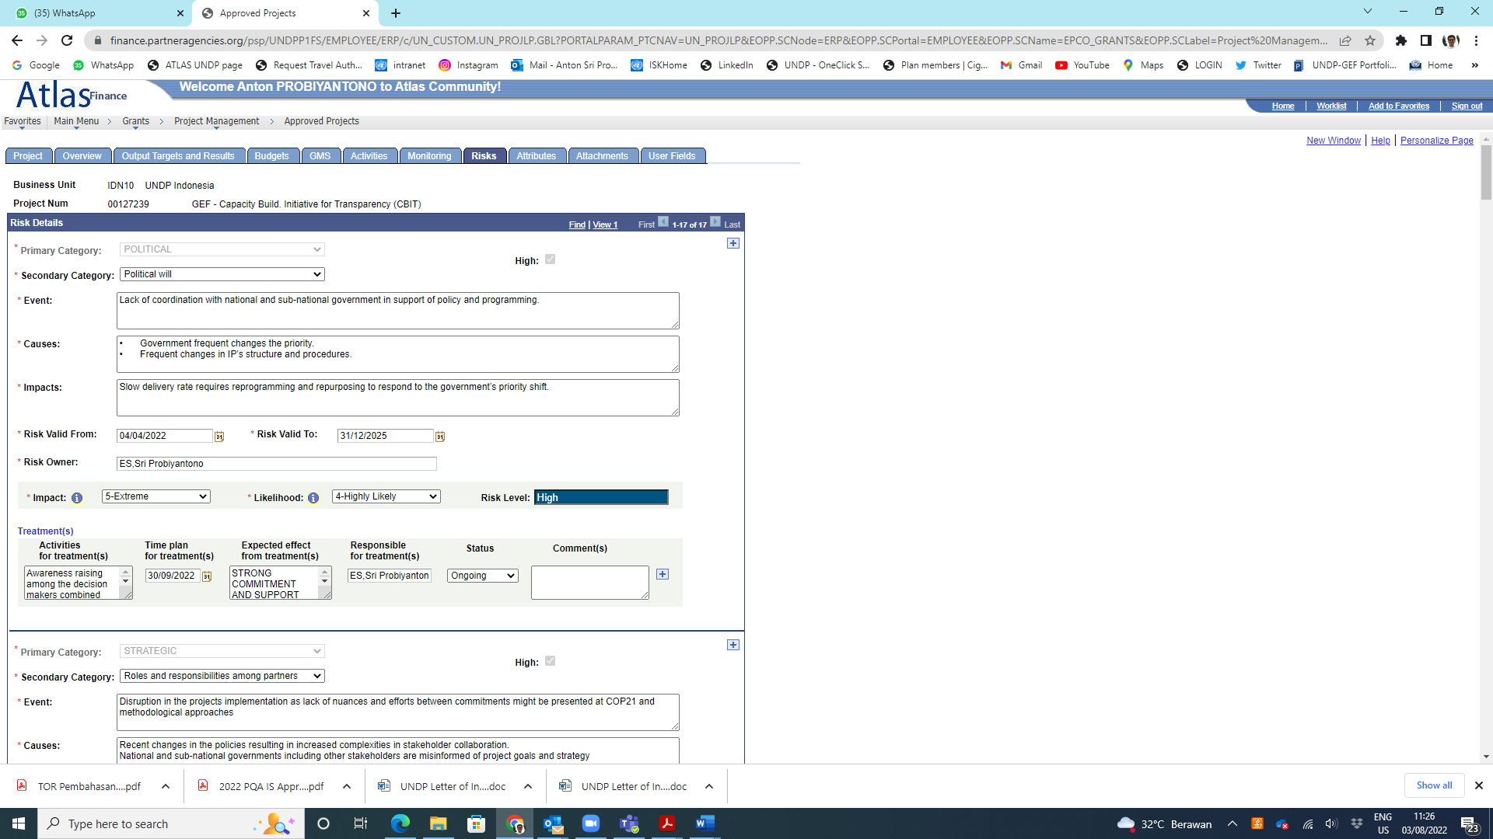 | 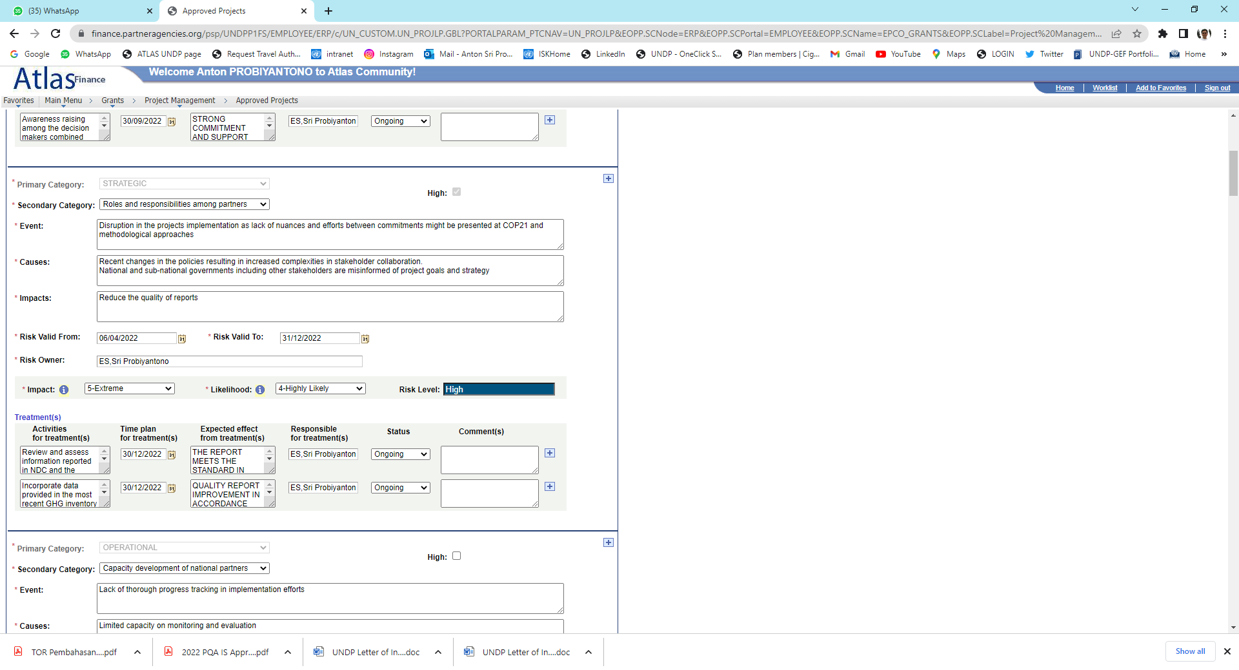
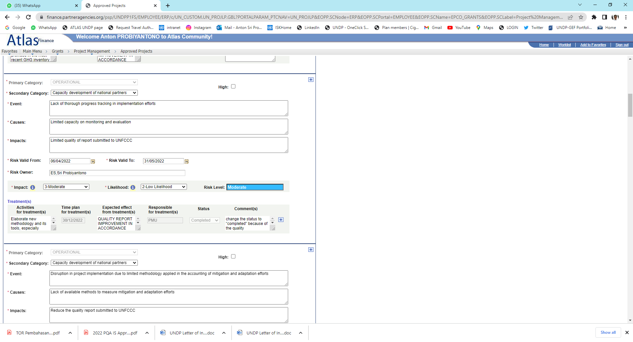 | 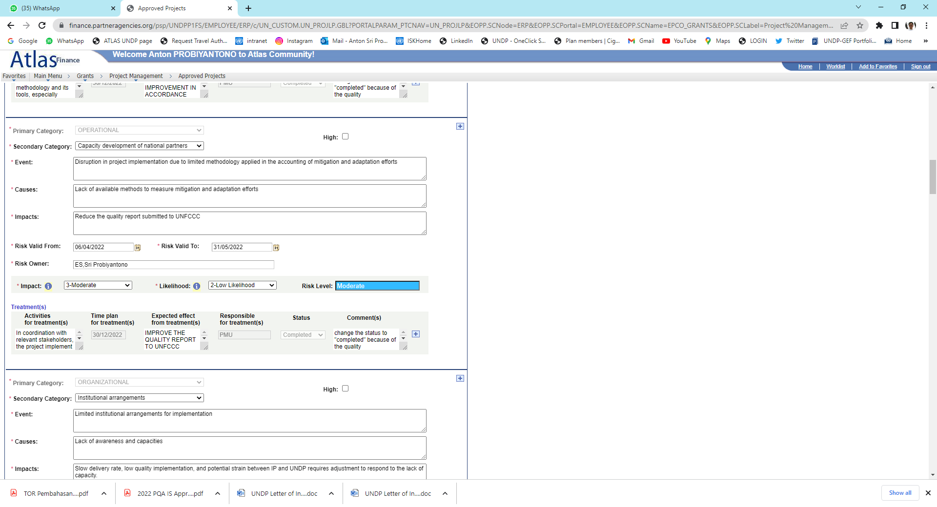
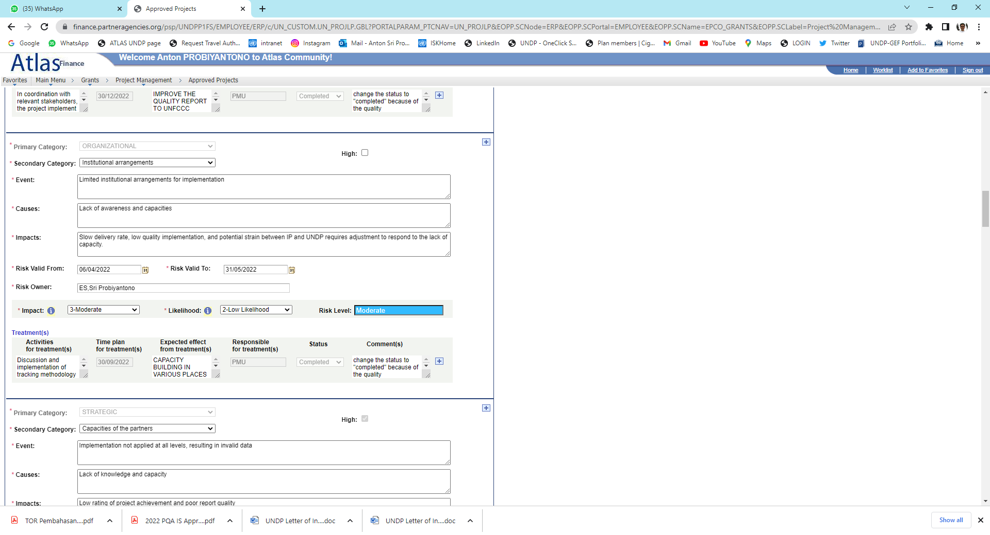 | 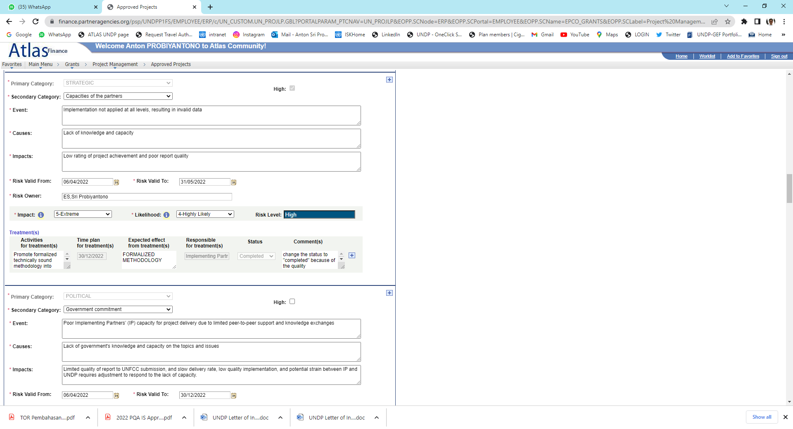
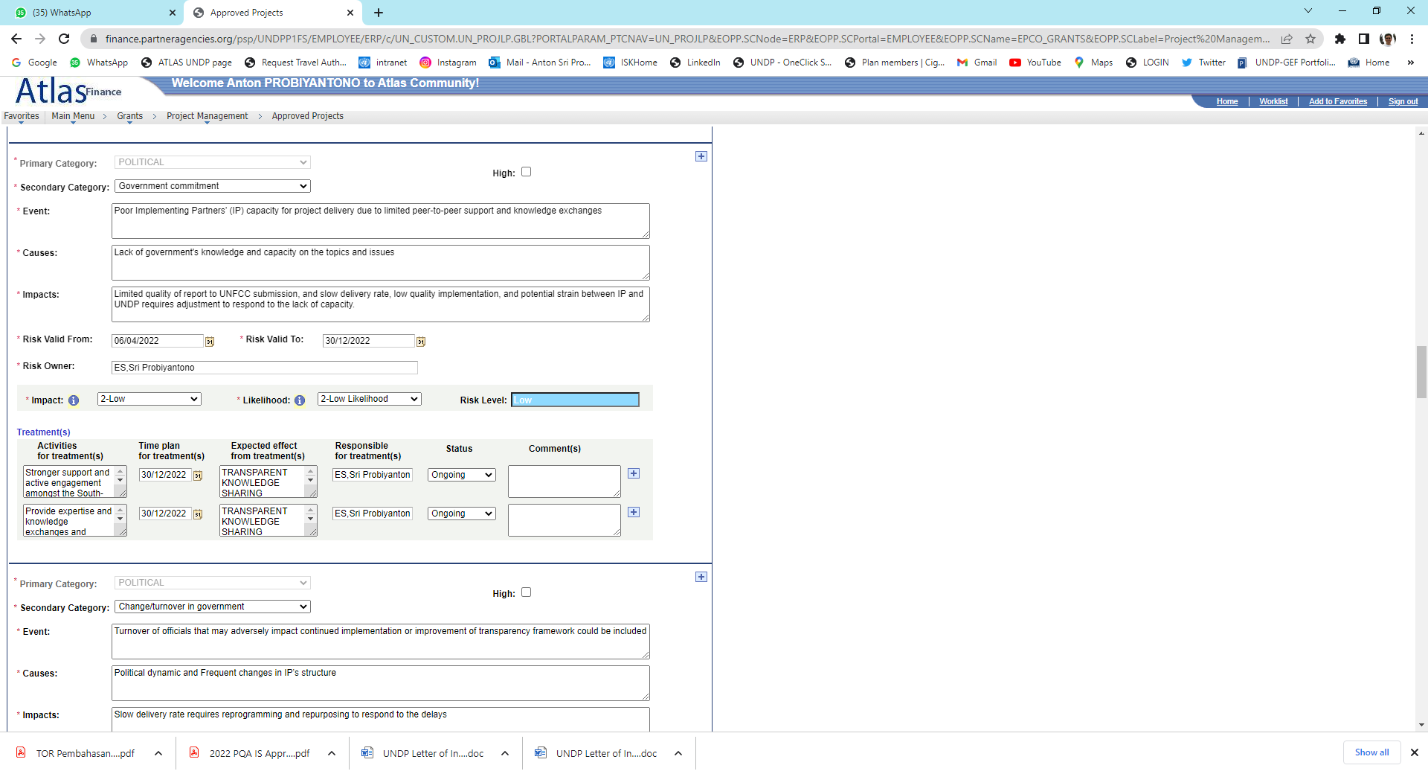 | 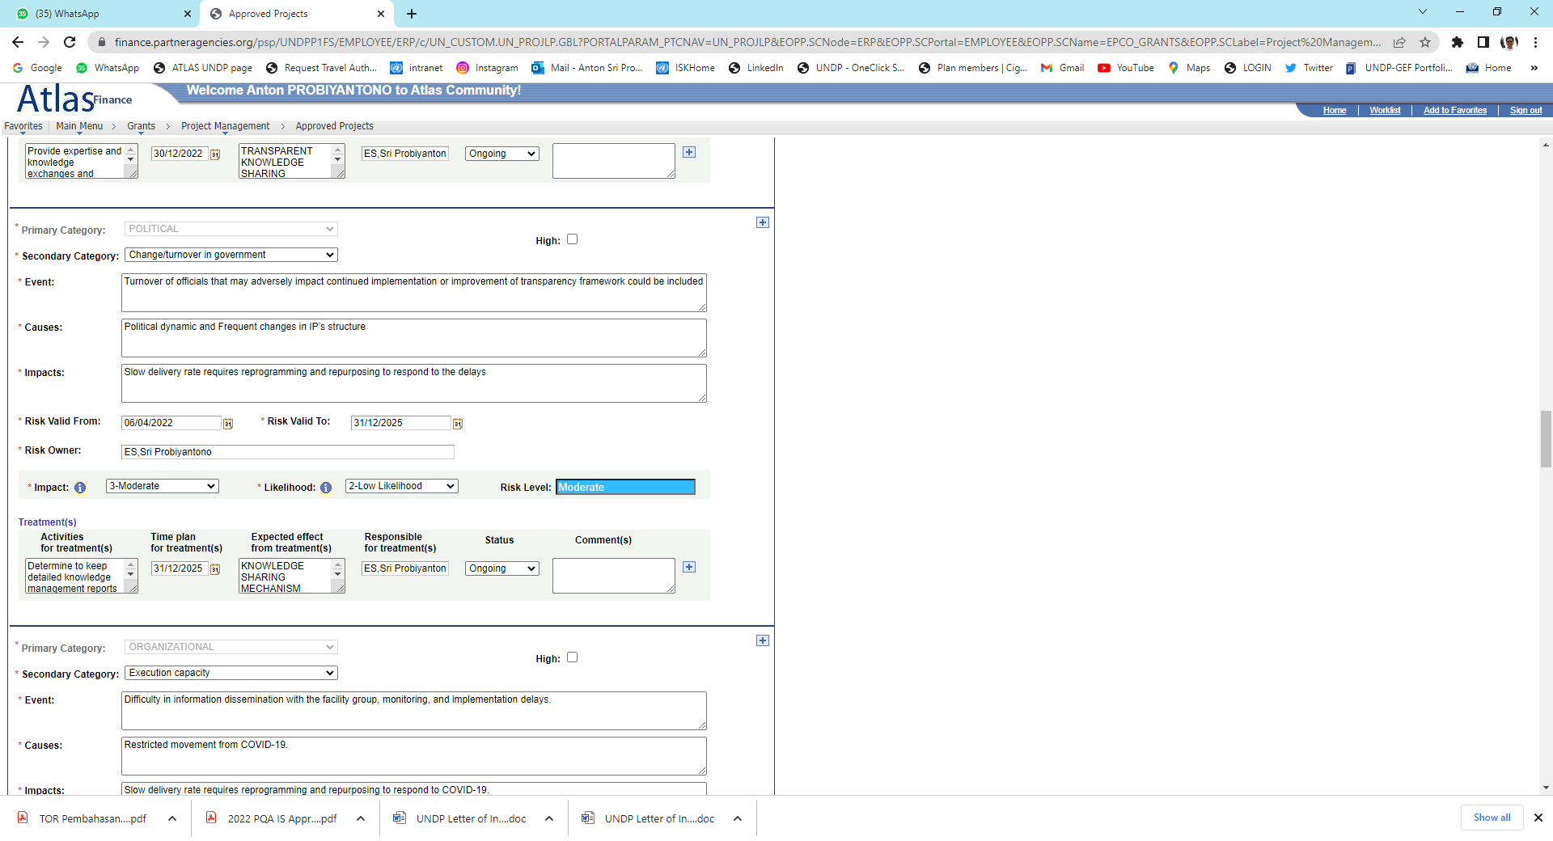
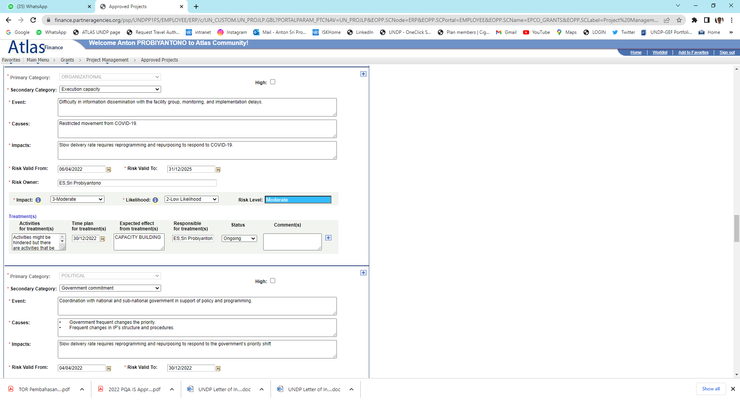 | 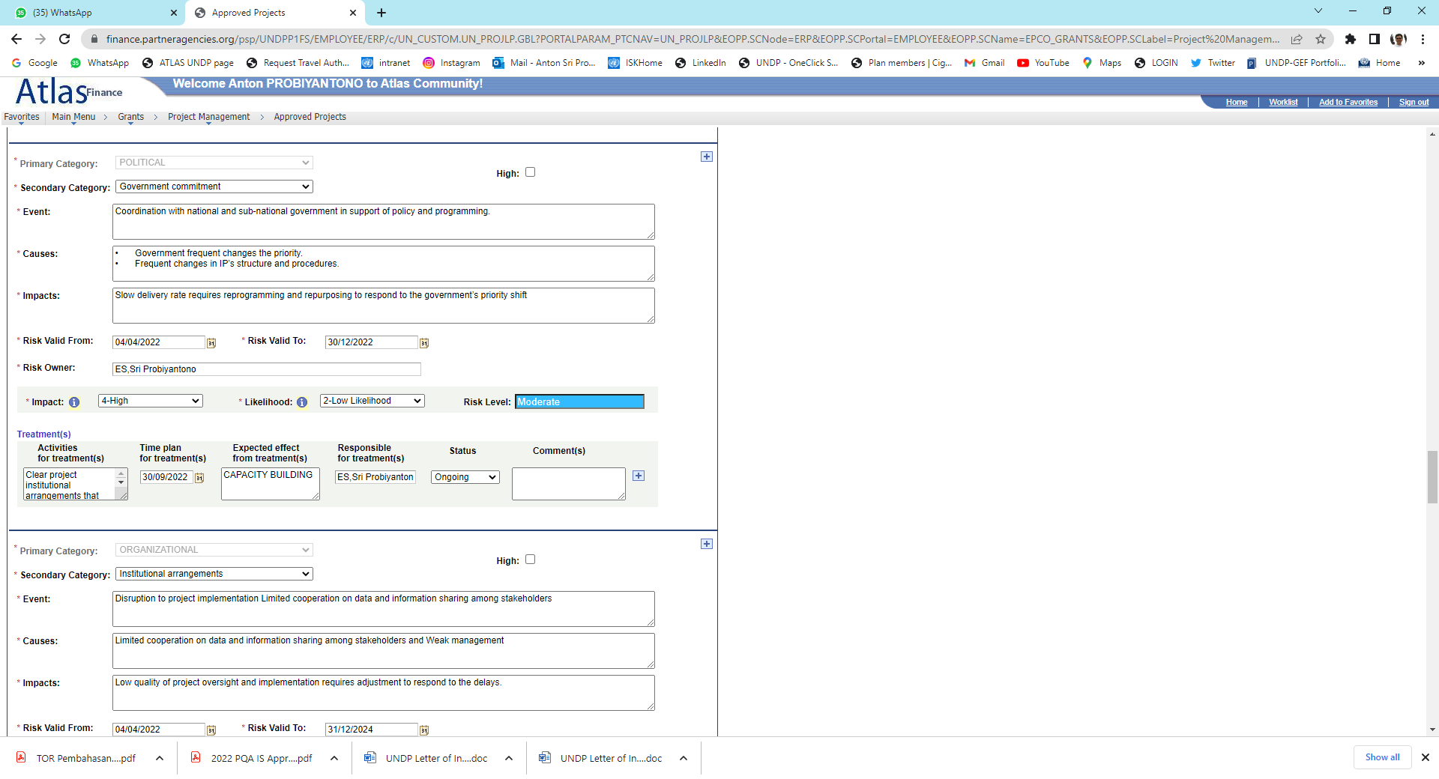
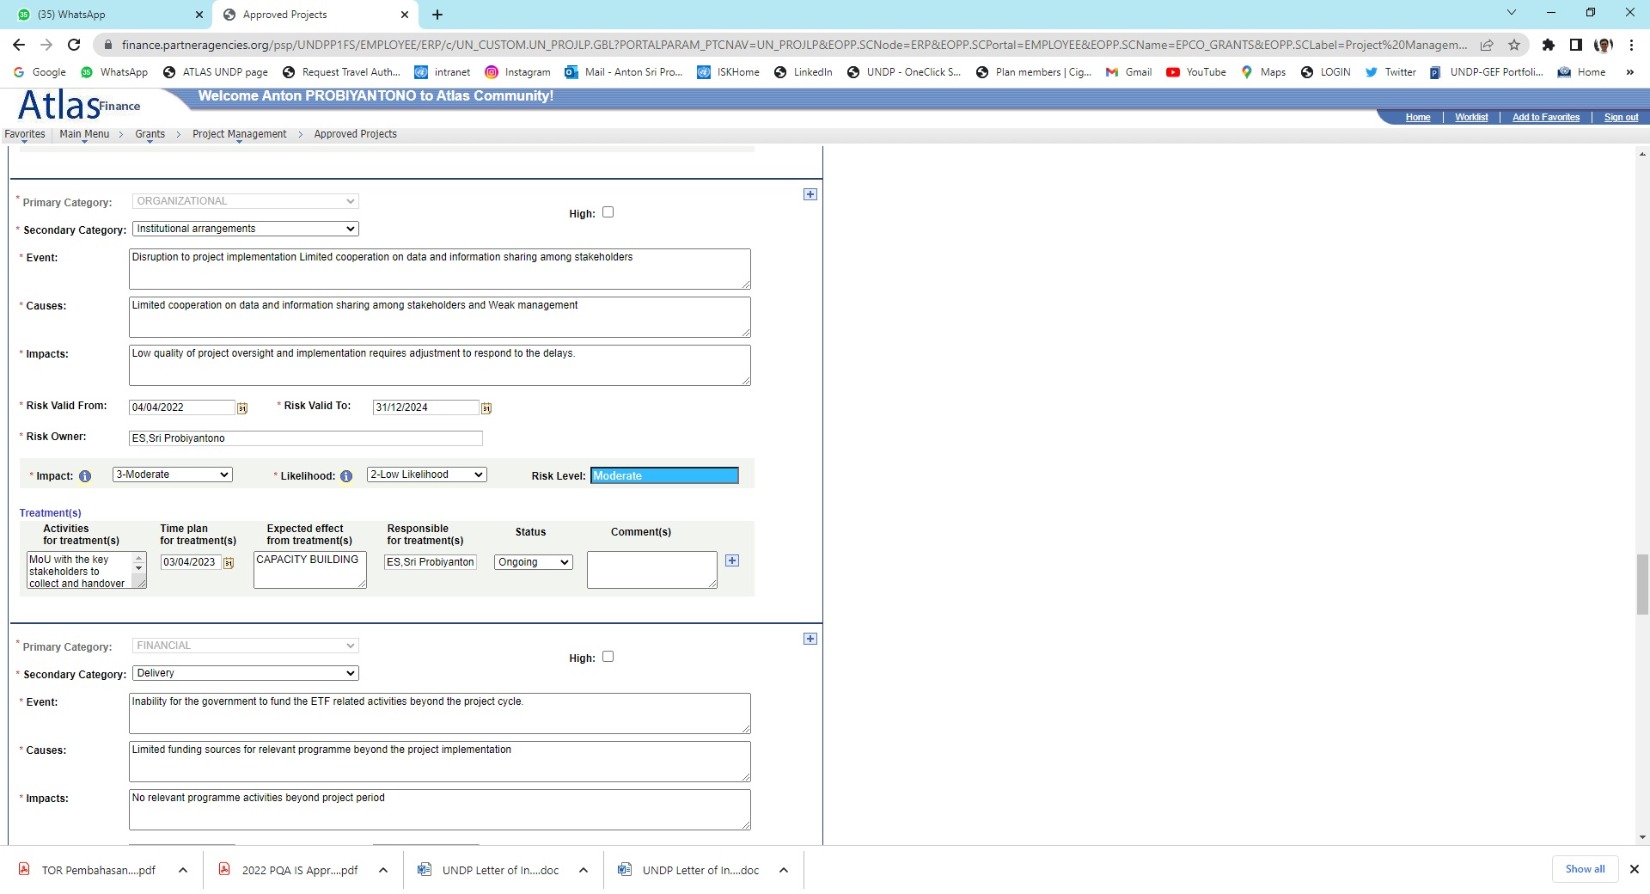 | 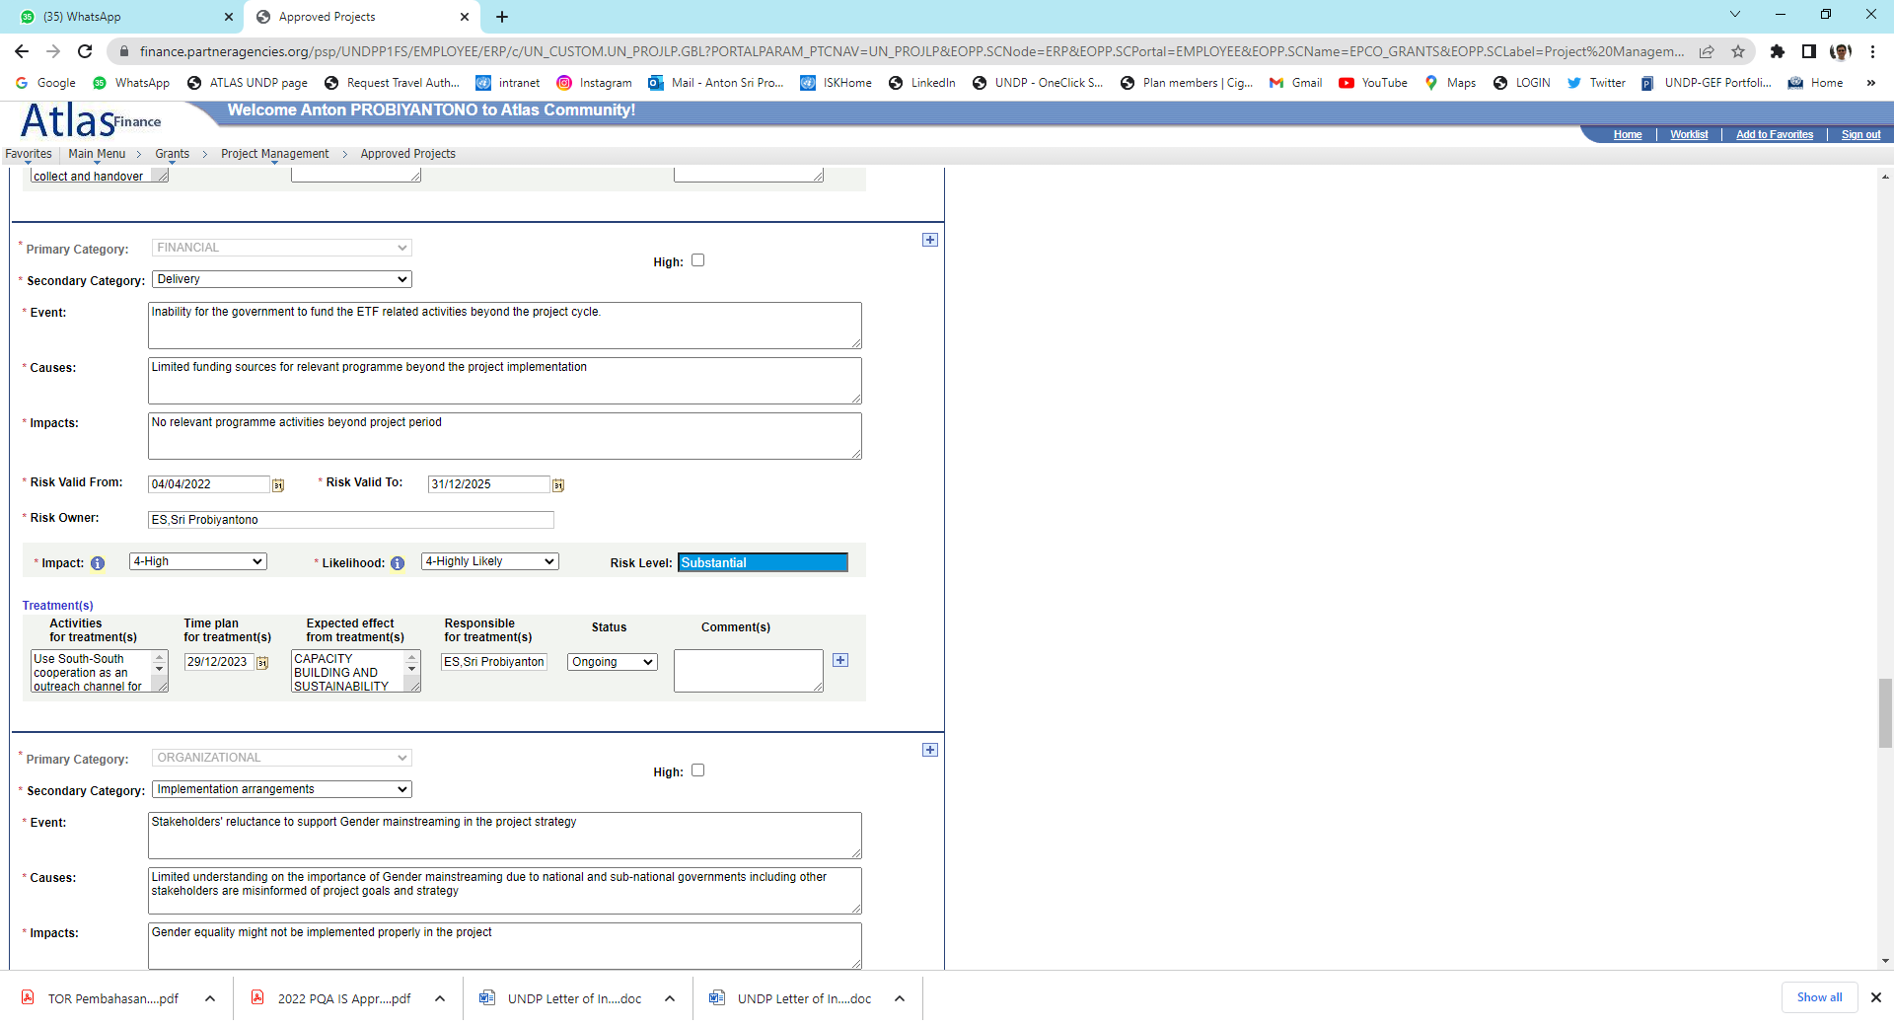
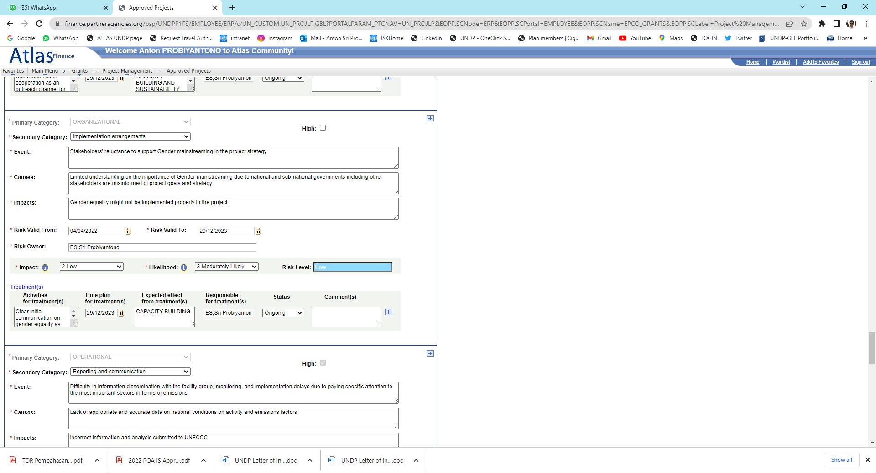 | 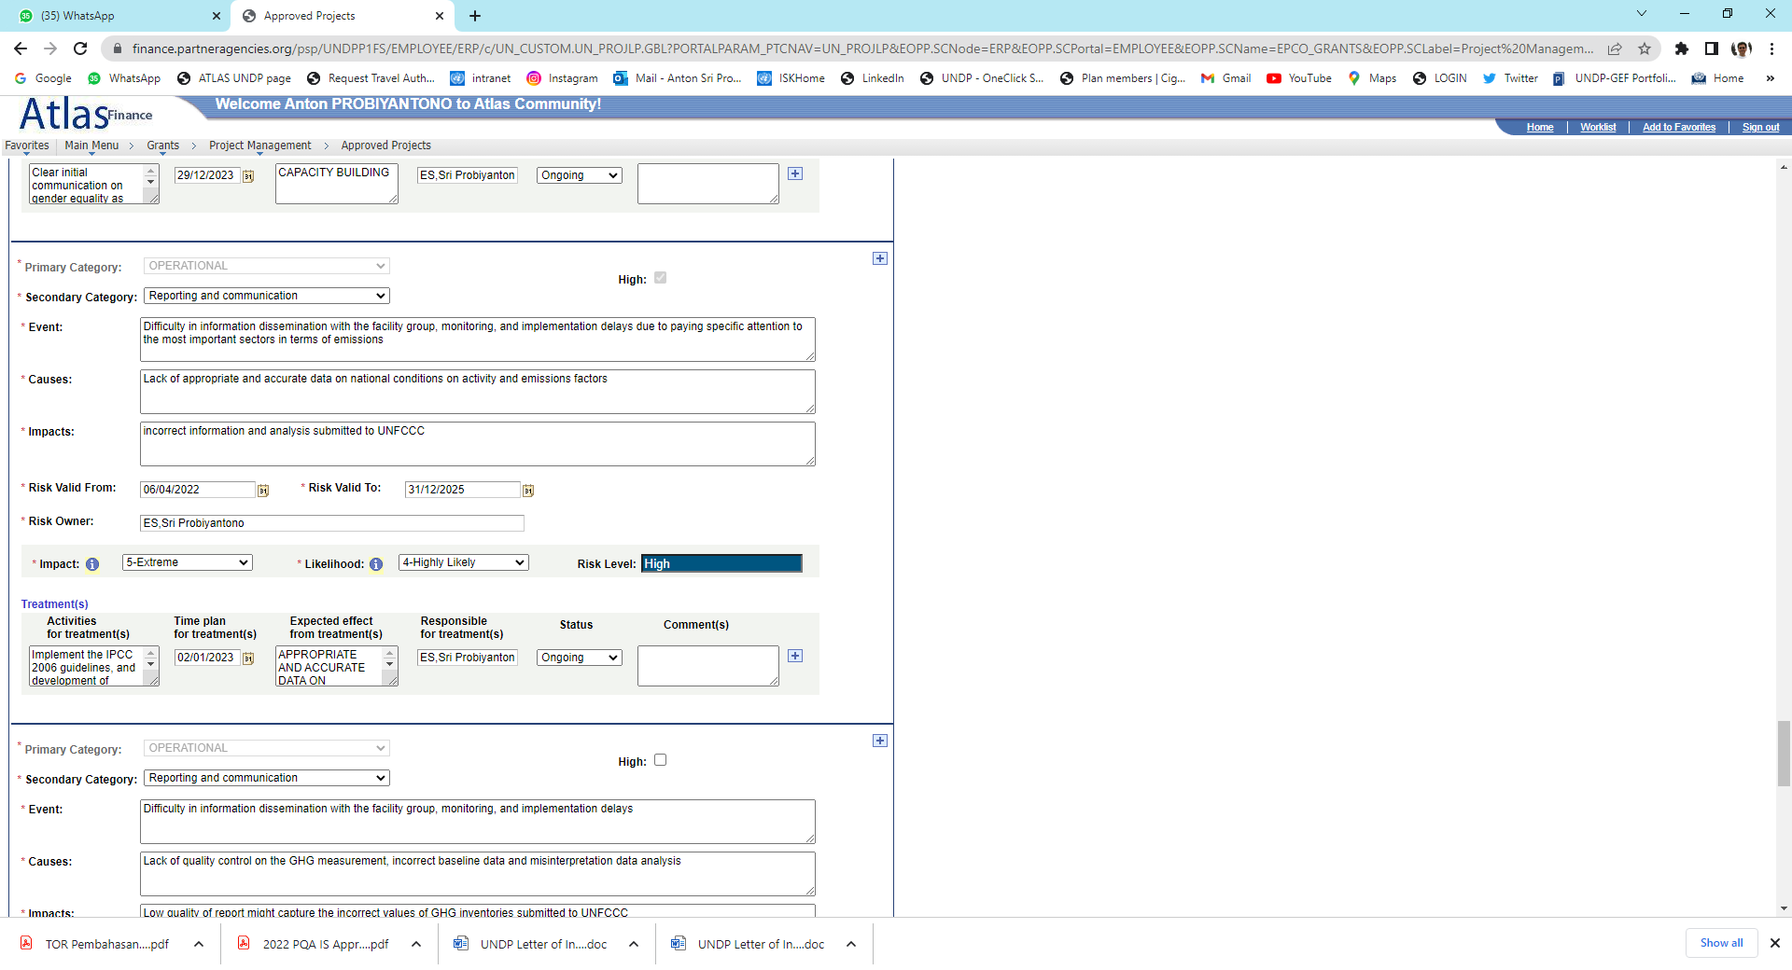
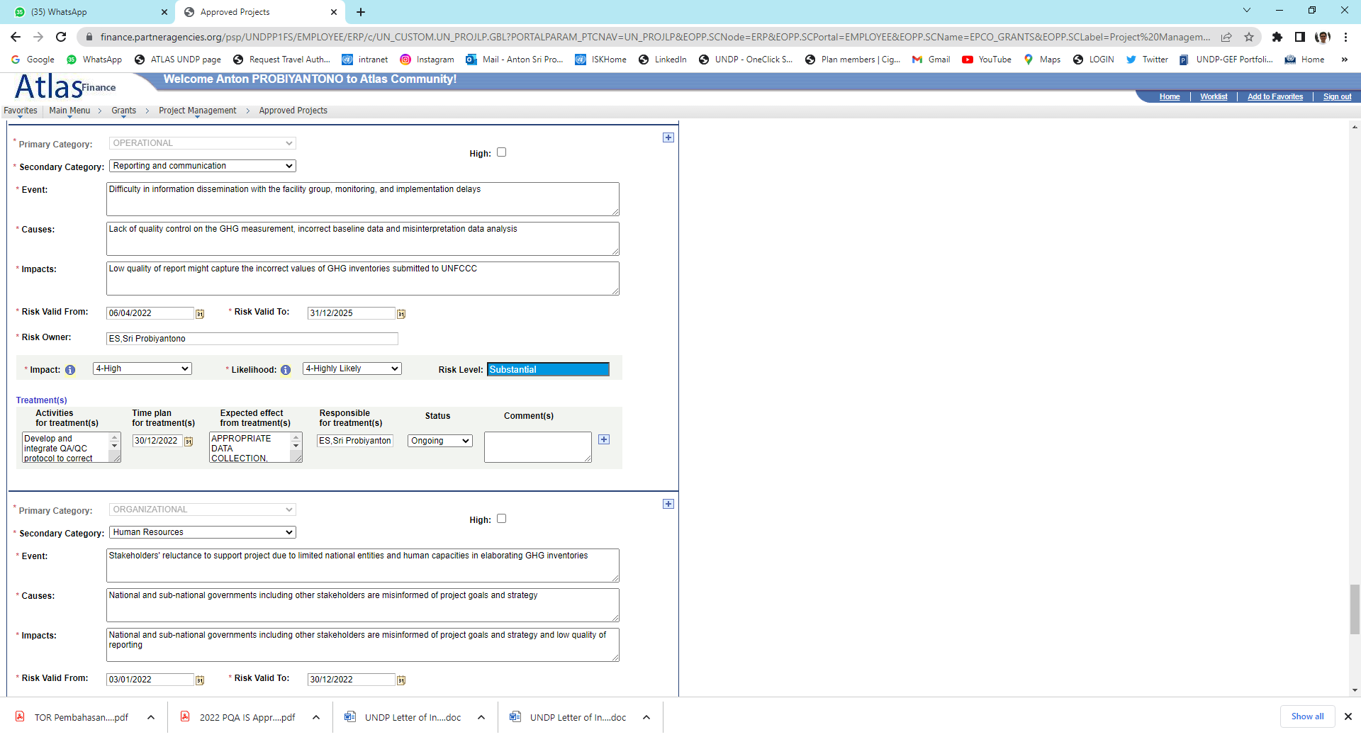 | 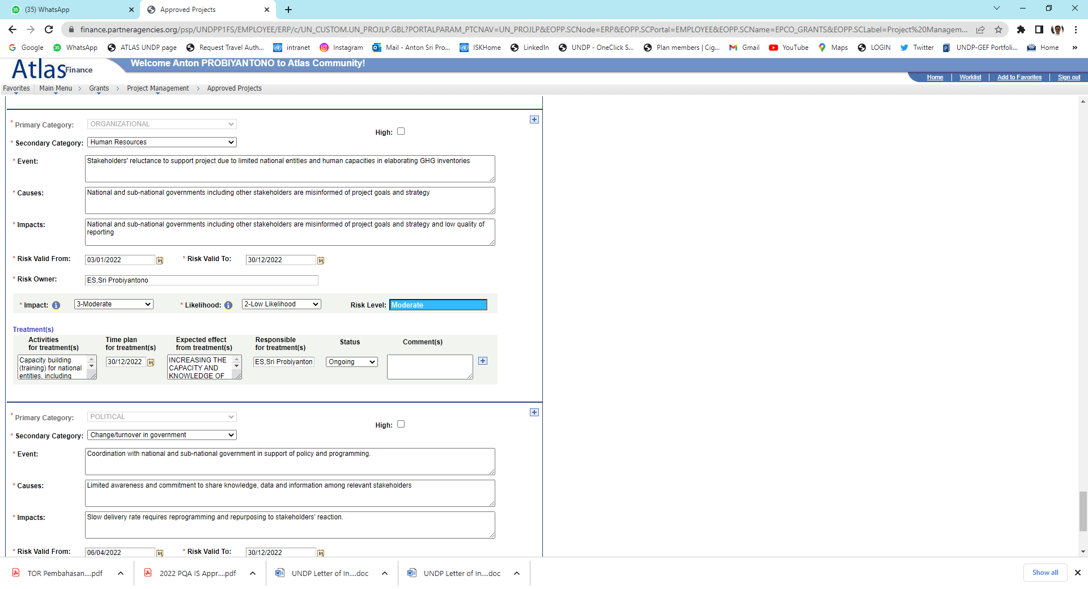
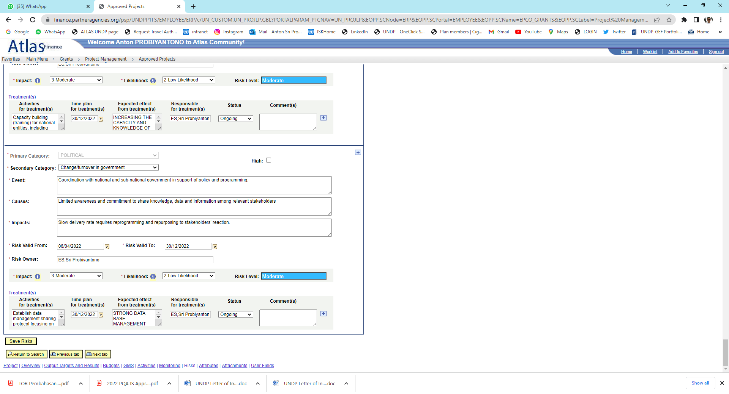

Risk Category | Event | Causes | Impact | Valid From  (dd/mm/yyyy) | Valid To  (dd/mm/yyyy) | Treatment status | Treatment activity description | Expected effect from treatment | High risk (Y/N) | Risk Owner  (Provide name, and position)

HARMONIZED APPROACH TO CASH TRANSFER (HACT) ASSURANCE ON IMPLEMENTING PARTNERS: Signed Prodoc AND RESPONSIBLE PARTIES: Signed LoA, RPA or PBP (Inputs to the HACT Dashboard)

Name of IP/RP | 1st Year: | FY 2022 | 2nd Year | FY 2023 | 3rd Year: | FY 2024 | 4th Year: | FY 2025 | 5th Year: | FY YYYY
 | Planned | Actual | Planned | Actual | Planned | Actual | Planned | Actual | Planned | Actual
1. CBIT Indonesia, Type of Agreement: Project Document (PRODOC) Total value: USD 1,900,000. Duration of Agreement: From 01/01/2022 to 31/12/2025 .
- HACT Micro Assess. | dd/mm/yyyy | dd/mm/yyyy | N.A. | N.A. | N.A. | N.A. | N.A. | N.A. | N.A. | N.A.
Risk level: | Choose an item. |  | N.A. | N.A. | N.A. | N.A. | N.A. | N.A. | N.A. | N.A.
- HACT Spot Check 1 | dd/mm/yyyy | dd/mm/yyyy | dd/mm/yyyy | dd/mm/yyyy | dd/mm/yyyy | dd/mm/yyyy | dd/mm/yyyy | dd/mm/yyyy | dd/mm/yyyy | dd/mm/yyyy
Result/Findings:
- HACT Spot Check 2 | dd/mm/yyyy | dd/mm/yyyy | dd/mm/yyyy | dd/mm/yyyy | dd/mm/yyyy | dd/mm/yyyy | dd/mm/yyyy | dd/mm/yyyy | dd/mm/yyyy | dd/mm/yyyy
Result/Findings⁹:
- HACT Audit | dd/mm/yyyy | dd/mm/yyyy | dd/mm/yyyy | dd/mm/yyyy | dd/mm/yyyy | dd/mm/yyyy | dd/mm/yyyy | dd/mm/yyyy | dd/mm/yyyy | dd/mm/yyyy
Result/Findings⁹:
2. <Name of IP/RP>, Type of Agreement: Choose an item. Total value: USD . Duration of Agreement: From dd/mm/yyyy to dd/mm/yyyy .
- HACT Micro Assess. | dd/mm/yyyy | dd/mm/yyyy | N.A. | N.A. | N.A. | N.A. | N.A. | N.A. | N.A. | N.A.
Risk level: | Choose an item. |  | N.A. | N.A. | N.A. | N.A. | N.A. | N.A. | N.A. | N.A.
- HACT Spot Check 1 | dd/mm/yyyy | dd/mm/yyyy | dd/mm/yyyy | dd/mm/yyyy | dd/mm/yyyy | dd/mm/yyyy | dd/mm/yyyy | dd/mm/yyyy | dd/mm/yyyy | dd/mm/yyyy
Result/Findings⁹:
- HACT Spot Check 2 | dd/mm/yyyy | dd/mm/yyyy | dd/mm/yyyy | dd/mm/yyyy | dd/mm/yyyy | dd/mm/yyyy | dd/mm/yyyy | dd/mm/yyyy | dd/mm/yyyy | dd/mm/yyyy
Result/Findings⁹:
- HACT Audit | dd/mm/yyyy | dd/mm/yyyy | dd/mm/yyyy | dd/mm/yyyy | dd/mm/yyyy | dd/mm/yyyy | dd/mm/yyyy | dd/mm/yyyy | dd/mm/yyyy | dd/mm/yyyy
Result/Findings⁹:
3. <Name of IP/RP>, Type of Agreement: Choose an item. Total value: USD . Duration of Agreement: From dd/mm/yyyy to dd/mm/yyyy .
- HACT Micro Assess. | dd/mm/yyyy | dd/mm/yyyy | N.A. | N.A. | N.A. | N.A. | N.A. | N.A. | N.A. | N.A.
Risk level: | Choose an item. |  | N.A. | N.A. | N.A. | N.A. | N.A. | N.A. | N.A. | N.A.
- HACT Spot Check 1 | dd/mm/yyyy | dd/mm/yyyy | dd/mm/yyyy | dd/mm/yyyy | dd/mm/yyyy | dd/mm/yyyy | dd/mm/yyyy | dd/mm/yyyy | dd/mm/yyyy | dd/mm/yyyy
Result/Findings⁹:
- HACT Spot Check 2 | dd/mm/yyyy | dd/mm/yyyy | dd/mm/yyyy | dd/mm/yyyy | dd/mm/yyyy | dd/mm/yyyy | dd/mm/yyyy | dd/mm/yyyy | dd/mm/yyyy | dd/mm/yyyy
Result/Findings⁹:
- HACT Audit | dd/mm/yyyy | dd/mm/yyyy | dd/mm/yyyy | dd/mm/yyyy | dd/mm/yyyy | dd/mm/yyyy | dd/mm/yyyy | dd/mm/yyyy | dd/mm/yyyy | dd/mm/yyyy
Result/Findings⁹:

GRANTEES (LOW VALUE GRANT AGREEMENT OR ON-GRANTING) TRACKING

Grantees (NGOs/CSOs) | Type of Contract | Current Contract Start Date | Current Contract End Date | Current Contract Value |  | Cumulative Contract Value under the Country Programme Cycle 2016-2020 (including with other projects)
 |  |  |  | IDR | USD | IDR | USD
- <N/A > | Select Contract | dd/mm/yyyy | dd/mm/yyyy
- <Name of Grantee> | Select Contract | dd/mm/yyyy | dd/mm/yyyy
- <Name of Grantee> | Select Contract | dd/mm/yyyy | dd/mm/yyyy

ONLINE PROJECT QUALITY ASSURANCE TRACKING

Project Quality Assurance | Rating Criteria | Quality Rating | Management Response (if any) | Status of Management Response
Latest Project QA: 2022  FY SELECT YEAR  Type Project QA:  Implementation QA  Overall Rating:  Satisfactory | Strategic | Highly Satisfactory
 | Relevant | Satisfactory
 | Social & Environmental Standards | Highly Satisfactory
 | Management & Monitoring | Satisfactory
 | Efficient | Satisfactory
 | Effective | Highly Satisfactory
 | Sustainability & National Ownership | Satisfactory

GRANT REGISTRATION (FOR PROJECT REGISTERED AT THE MINISTRY OF FINANCE)

Name of IP/RP | 1st Year: | FY YYYY | 2nd Year | FY YYYY | 3rd Year: | FY YYYY | 4th Year: | FY YYYY | 5th Year: | FY YYYY
 | BAST in IDR | BAST in USD | BAST in IDR | BAST in USD | BAST in IDR | BAST in USD | BAST in IDR | BAST in USD | BAST in IDR | BAST in USD
MoF Grant Registration No: ; Type of Grant: SELECT the type of grant in accordance with Indonesian grant regulation; Total grant registered: USD .
- 1st BAST Goods
- 1st BAST Services
Date: | dd/mm/yyyy |  | dd/mm/yyyy |  | dd/mm/yyyy |  | dd/mm/yyyy |  | dd/mm/yyyy
- 2nd BAST Goods
- 2nd BAST Services
Date: | dd/mm/yyyy |  | dd/mm/yyyy |  | dd/mm/yyyy |  | dd/mm/yyyy |  | dd/mm/yyyy
- 3rd BAST Goods
- 3rd BAST Services
Date: | dd/mm/yyyy |  | dd/mm/yyyy |  | dd/mm/yyyy |  | dd/mm/yyyy |  | dd/mm/yyyy
- 4th BAST Goods
- 4th BAST Services
Date: | dd/mm/yyyy |  | dd/mm/yyyy |  | dd/mm/yyyy |  | dd/mm/yyyy |  | dd/mm/yyyy

Project Output Linking: https://intranet-apps.undp.org/UNDP.HQ.CPS2018/app/IDN/programme/59/projects
ROAR 2020: https://intranet-apps.undp.org/ROAR2020/Pages/STD/Workflow.aspx?ou=IDN&bureau=RBAP&menu=IDN . Evidence
ROAR 2019: https://intranet-apps.undp.org/ROAR2019/Pages/STD/StatusReport.aspx?ou=IDN&bureau=RBAP&menu=UNIT
PAR S1 to complete the expenditure table reporting Jan-Jun. PAR S2 to complete the expenditure table Est.Jan- Dec
Please refer to project target delivery on reporting period.
Please check the requirement in the Project Document. Project Initiation Plan (PIP) is also required to prepare a Project Report.
Please check the requirement in the Project Document and the Cost Sharing Agreement / Financing Agreement with the Donor. If not stated, please consult with the Donor on the expected reporting requirement.
Project Board Meeting is required for all types of projects, including DIM projects.
HACT Dashboard: https://intranet-apps.undp.org/undp.hq.apps.hact/Pages/MicroAssessment.aspx?Office=IDN&progId=852
Examples of Results/Findings: Bank reconciliations are not regularly prepared or reviewed; Payments are not authorized by an independent officials; The partner does not have a reliable accounting system that facilitates timely & accurate recording & reporting of transactions; The partner does not have adequate accounting/procurement/HR policies & procedures; There are no segregation of duties between requisition/order/receiving/bank reconciliation/payments processing, etc.; The partner’s financial records are not audited regularly by an independent third party; Physical verification of assets is not performed regularly.

