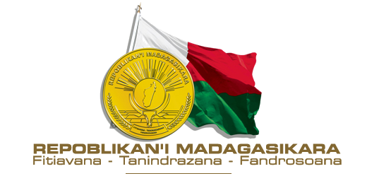


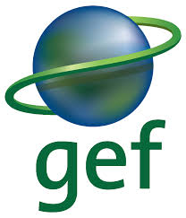

RAPPORT

INCEPTION WORKSHOP OF THE PROJECT
« BUILDING AND STRENGHTENING MADAGASCAR’S NATIONAL CAPACITY TO IMPLEMENT THE TRANSPARENCY ELEMENTS OF THE PARIS AGREEMENT»

September 25, 2019.

HOTEL IBIS
ANTANANARIVO

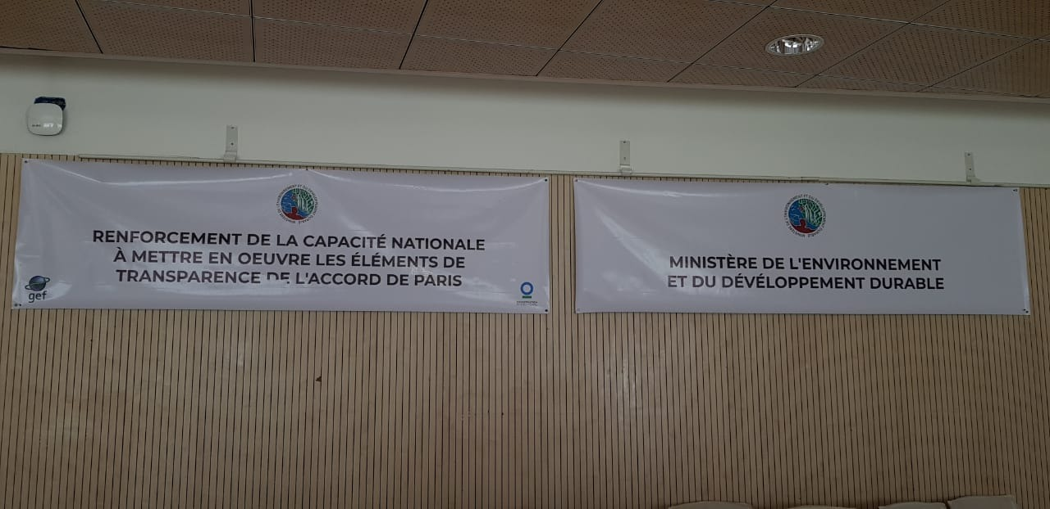

TABLE OF CONTENTS

1 INTRODUCTION 2
2 PARTICIPANTS 3
3 WORKSHOP PROCEEDINGS 3
3.1 Launch of the CBIT Madagascar Project 3
3.2 Presentations 3
4 PLENARY SESSION 6
4.1 Question and answer session, discussions and recommendations 6
5 CLOSING 8
6 MEETING BETWEEN CIGEF AND CBIT-MADAGASCAR PROJECT STAFF 8
ANNEXES 10
Annex I : Termes De Reference 10
Annex II : Agenda Provisoire (Inception Workshop Agenda) 11

INTRODUCTION
Article 13 of the 2015 Paris Agreement establishes the “Enhanced Transparency Framework” (UNFCCC 2015). The framework was established to enable the tracking, comparing and understanding of national commitments worldwide to fight climate change. The “transparency framework” requires countries to regularly provide:
- A National inventory of greenhouse gas emissions (by sources) and removals (by sinks);
- Information necessary to track progress toward achieving their Nationally Determined Contribution (NDC);
- Information related to climate change impacts and adaptation
- Information on climate change adaptation and mitigation, financial, technology transfer, capacity building support needed and received by developing countries
- Information on climate change adaptation and mitigation, financial, technology transfer and capacity building support provided by developed countries

At the 21st Conference of the Parties (COP), developing countries called on developed countries to provide more support to help them comply with the enhanced transparency provisions. The countries thus decided to establish the "Transparency Capacity Building Initiative" which aims to strengthen institutional and technical capacities in the pre- and post-2020 period. A CBIT global coordination platform has also been set up to share lessons learned and attract new partners. In this context, the COP to the Paris Agreement in paragraph 86 urges the Global Environment Facility (GEF) to take steps to support the establishment and continuation of the Capacity Building Transparency Initiative and thus establish a new trust fund.

As a Party to the Paris Agreement, Madagascar received financial support from the Global Environment Facility in the amount of US$ 1,344,495 to implement a project entitled "Strengthening national capacity to implement the transparency elements of the Paris Agreement". This is a 24 month project that will be co-executed by the Ministry of Environment and Sustainable Development through the National Office for Climate Change, Carbon and REDD+ (BNCCCREDD+) and Conservation International.

To this end, a workshop to launch the project "Strengthening national capacity to implement the transparency elements of the Paris Agreement" was organized by the Ministry of Environment and Sustainable Development (MEDD) in partnership with Conservation International on September 25, 2019 at the Ibis Hotel, Antananarivo. The main objectives of this workshop were to:
- Launch the CBIT Madagascar Project
- Raise awareness about the project and foster stakeholder ownership;
- Encourage all actors and parties involved and concerned by the project to discuss possible collaborations for the effective implementation of the project; and
- Collect comments on the main lines of activities, the performance monitoring plan and the environmental and social management framework of the project.

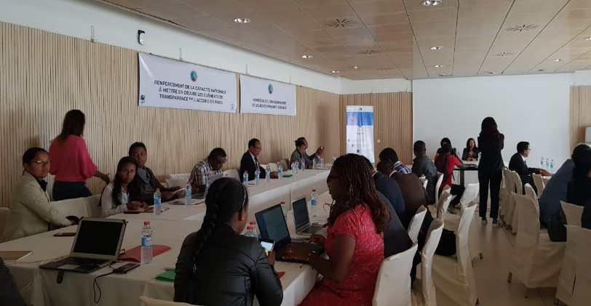
PARTICIPANTS
The inception workshop was attended by eighty-four participants (30 women and 54 men) representing Director-Generals and Technical Directors from the various sectors (public and private), regional directors from Madagascar's 22 regions, UN agencies, civil society organizations, non-governmental organizations and research centers.

WORKSHOP PROCEEDINGS

Launch of the CBIT Madagascar Project

Opening Remarks by Mrs. Sahondra Rajoelina, the Country Director of Conservation International-Madagascar: Mrs Rajoelina gave opening remarks where she thanked participants for their willingness to work together towards achieving Madagascar’s commitment to the Paris Agreement transparency framework. She also reminded participants that this workshop is a follow-up to the various consultation workshops held as part of the preparation of the CBIT project document. The CBIT project is currently entering the implementation phase and will be co-executed by BNCCCREDD+ and Conservation International.

Official launch of the workshop/CBIT Project by Mrs Lovakanto Ravelomanana, the Director of BNCCREDD+ : The floor was then given to Mrs Ravelomanana, the Director of BNCCREDD+. In her speech, she thanked the participants on behalf of the MEDD for attending the inception workshop. She noted that in response to the impacts of climate change, initiatives have been taken by the Government of Madagascar through adherence to the various climate treaties, namely, the UNFCCC, the Kyoto Protocol and the Paris Agreement ratified by Madagascar in 1998, 2003 and 2016 respectively. She also pointed out that Madagascar has developed its National Determined Contribution (NDC), which is proof of its commitment to fight climate change. She also noted that Madagascar is committed to fulfilling Article 13 of the Paris Agreement. The official launch of the workshop was followed by a series of presentations outlined below.

Presentations
Presentations were structured as follows:

Presentation 1: Transparency of the Paris Agreement and steps undertaken, by the National Project Director of the project, BNCCCREDD+

This presentation focused on the clarification and explanation of the Paris Agreement and the decisions adopted at the 21st Conference of the Parties on the establishment of the enhanced transparency framework, the establishment of the CBIT. In addition, this intervention also recalled the main stages of the CBIT process in Madagascar, including the holding of various workshops for the preparation of the Project Document (ProDoc) which began in August 2018 and was completed in October 2018. The Project Document was approved by the CEO of the GEF in June 2019.
Presentation 2: Project (objective, component, outcomes and outputs), by the project coordinator, BNCCCREDD+

This presentation highlighted the context of the transparency framework and the implementation of CBIT. It stressed on the various constraints and deficiencies encountered by the sectors during the preparation of National Communications. The main sectors concerned by the project were mentioned, as well as the duration of the project, the project amount and the GEF executive agency and implementing agencies. In addition to clarifying the project objectives, the project components, as well as the expected results (outcomes) and outputs of each component were also explained:
- Component 1 and its outcomes and outputs focus on the development of strategies and instruments for the implementation of the Paris Agreement's transparency framework and the elaboration of recommendations for the establishment of a sectoral monitoring system,
- Component 2 and its outcomes and outputs seek to improve accessibility to the various technological tools for establishing the MRV system for all sectors for monitoring greenhouse gas emissions (Measurement, Reporting, Verification), which consists of a series of tools for processing information on emission factors, adaptation and mitigation options, greenhouse gas inventory software. This component also aims to establish a database management system.
- Component 3 and its outcomes and outputs - it was pointed out that training on CDN monitoring, GHG inventories, MRV system will be carried out during the two years of the project targeting government representatives, technicians, technical and financial partners, research centers, civil societies working in the environment and climate change, and members of the national committee on climate change. Training modules will be developed as follows

Presentation 3: Transparency of the Paris Agreement, the role of the GEF in the "Capacity Building Initiative for Transparency, CBIT" and GEF procedures, by the CI/GEF representative

During the presentation, it was stressed that the GEF is an international partnership composed of governments, international institutions, CSOs, private sectors and its main objective is to address global environmental issues. It was also explained that the GEF funds projects which fall under its five thematic areas: biodiversity, climate change, land degradation, international water, chemicals and waste.

In the GEF 7, impact programmes have been added relating to food, land use, sustainable cities, sustainable forest management. It was also stressed that the GEF supports multilateral agreements, including the UNFCCC. Regarding the link between the Paris Agreement and the GEF, it was explained that during the negotiations, it was recognized that it was necessary to assist countries in reporting on progress made in terms of NDC. The parties to the UNFCCC thus requested the GEF to establish the CBIT with a view to updating the elements of transparency as stipulated in Article 13 of the Paris Agreement.

In November 2016, the GEF established the CBIT trust fund. CBIT thus helps countries to implement key elements of transparency. It was also noted that Madagascar's CBIT project is aligned with the objectives of CBIT. It was also noted during the presentation that all CBIT projects must have a CBIT focal point and are required to share information with the global CBIT coordination platform. It was stressed that the logos of the GEF, BNCCCREDD+ and CI as well as the recognition on the financial support provided by the GEF must appear in all reports, publications, blogs.

Presentation 4: Environmental and social management framework by Conservation International Project Lead

This presentation highlighted the GEF standards and requirements for environmental protection, social protection, gender mainstreaming and CI policy in the implementation of a project. These policies include (i) the accountability and grievance mechanism, aimed at compiling and managing complaints in a timely manner, (ii) gender mainstreaming, aimed at ensuring that women receive respect for their dignity and human rights, and receive compatible social and economic benefits, (iii) stakeholder engagement to ensure that stakeholders are involved and consulted during all phases of the project.

Presentation 5: Presentation on national ownership by the Project Technical Coordinator
This intervention highlighted the roles of stakeholders in the implementation of the project, including (i) the steering committee which will be responsible for regular project monitoring, PTA approval, budget, reporting reviews, (ii) the executing agency composed of BNCCCREDD+ and Conservation International which will be mainly responsible for coordination, monitoring, evaluation and financial management, (iii) the DREDDs of the 22 regions, which will monitor the implementation of the project at the regional level as well as data collection and transfers at the level of the project management unit

Presentation 6: Main lines of activities, by the Responsible of Monitoring and Evaluation
In this presentation, different activities of the project were presented to stakeholders:

(i) Activities in component 1 Strengthen institutional arrangements, national policies and measures and coordinating within national institutions and all relevant sectors to meet the requirements of the Paris Agreement transparency framework aimed to assess institutional arrangements that meet the requirements of the Paris Agreement transparency framework, to develop policies, strategies and programs that improve transparency in climate monitoring, and to develop guidelines for the implementation of activities related to the Paris Agreement transparency framework.

(ii) For Component 2: Address key technology gaps to monitor GHG emissions and results of climate interventions through the development and dissemination of relevant tools, activities will focus on the establishment of a transparent management system to monitor GHG emissions, and MRV system and the creation of a website to share information and experiences .

(iii) Finally, for component 3 Capacity building for relevant national agencies and stakeholders on transparency s, activities will focus mainly on training of key actors on new MRV systems, national communications, CDN monitoring procedures, improvement of GHG inventories.

This presentation also focused on the explanation of methodologies to be applied and the project indicators.

In terms of methodology, for component 1, consultants will be hired to evaluate sectoral data, develop recommendations to strengthen policies and strategies, develop an operational CDN plan, develop protocols to collect sectoral GHG emissions data, develop protocols to collect data.

Regarding the methodology for component 2, national/international consultants will be recruited to: (i) develop a website and the project's communication strategy, (ii) integrate all information into the CBIT Global Coordination Platform, (iii) develop emission factors for mitigation sectors, (iv) develop guidelines for monitoring sectoral GHG emissions, (iv) articles will be published in newspapers, (v) equipment (computer, software, etc.) will be given to the sectors directly concerned by the project as well as for the DREDDs of the 22 regions and ((vi) consultants will be hired to compile lessons learned and good practices from MRV initiatives, (vii) and information days will be organized

For component 3, as a methodology, it was explained that trainings od stakeholders will be organized, and training modules will be developed.

Concerning the indicator of each component: (i) number of operational CDN plans and number of monitoring plan developed, (ii) the number of sectoral policies including the CDN, (iii) number of sectoral monitoring systems and MRV frameworks established, (iv) number of sectoral policies evaluated, (v) number of reports with recommendations, number of operational implementation plans of the CDN, number of sectoral policies/strategies developed or updated, number of sectoral data collection protocols (mitigation and adaptation), number of publications produced, number of information days organized, number of carbon registries established, number of participation of Madagascar in international events, number of emission factors developed for the mitigation sector, number of metadata systems developed, number of MRV systems developed, number of MRV reports prepared, number of modules developed and number of training conducted.

Presentation 7: Perspectives (Next steps) by the Project Lead from Conservation International
This presentation was focused on the activities that will be carried out over the next three months. These include the preparation of memoranda of understanding, the signature of grant agreements with the sectors concerned, the organization of a steering committee meeting including the validation of the PTA and budget, the preparation of the manual of procedures, the development of the M&E plan and data collection tools, the review and update of the safeguard policies.

PLENARY SESSION

Question and answer session, discussions and recommendations
Following the presentations, the following points were raised during the question and answer session:
- The project's intervention area: The project operates throughout Madagascar. The sectors at Regional and National level are concerned. Data collection mechanisms will be put in place to ensure reliable data. Regarding the sectors at the regional level, the Regional Directorates for the Environment and Sustainable Development will ensure the organization of data collection. Since we are talking about transparency, inventories will be made with the IPCC software.

- About the institutional arrangement: the Paris Agreement is for the medium and long term. Currently, we are in CBIT Phase 1. In the next phase we will go down to the level of the municipalities. For data collection, agreements will be established with the various sectors and the data should represent the reality on the ground.

- Project duration: The project duration is two years. The structures will be in place and the National Committee for Climate Change will be revitalized. A project financed by AFD will strengthen capacity for the collection of data on adaptation and mitigation under the Paris Agreement.

- The creation of data management systems: Statistical data: There is a statistical law governing statistics and a National Council for Statistical Information which coordinates the production of statistical data in Madagascar such as environmental statistics and statistical needs for environmental management. The GHG data represent the reality in Madagascar. The INSTAT is still the reference. Madagascar has 20 years of experience in GHG inventory. INSTAT is one of the partners since it has statistical data from the different sectors. Malagasy experts gave their opinions on the data according to the situation. In the MRV framework, for example, the evolution of INSTAT's forest area was used. For the reporting, the BNCCC has always collaborated with INSTAT.

- Roles of the project focal points and approaches to carry out the tasks: GHG emission mitigation, several sectors (Forests, Energy, Waste, Transport) collaborate with the MEDD to reduce GHG emissions. Implementation of data collection at the sector level.
Collect system:
- Establish a collaboration agreement between MEDD and other sectors
- At the regional level, Focal Points within DREDDs collect data
- Equipment provision and capacity building
- Develop ToRs of Focal Points within DREDDS and protocol of collaboration

- Private sector access to GEF and GCF funds: Private sector has access to GEF funding: The private sector could be the Executing Agency. There is also a CSO platform created by the GEF.
- Contribution of the private sector in the implementation of the project: The private sector could provide GHG data.

- Exchange and sharing of experiences: For CI's CBIT portfolio, there is already an exchange platform. There is also the annual global CBIT meeting. CBIT Focal Point in Madagascar attends this annual meeting.

- It is anticipated that lack of GHG data and low quality GHG data may slow down project implementation. There is need to plan how data will be cleaned and moved from sectors in-order to save time and avoid delays.

- Need to strengthen local capacity by triangulating both local and international expertise and build on Malagasy structures, systems and processes.

- Knowledge and lesson sharing across CBIT countries within CIGEF and globally is critical

- It is anticipated that lack of GHG data and low quality GHG data may slow down project implementation. There is need to plan how data will be cleaned and moved from sectors in-order to save time and avoid delays.

- Need to strengthen local capacity by triangulating both local and international expertise and build on Malagasy structures, systems and processes.

- Knowledge and lesson sharing across CBIT countries within CIGEF and globally is critical

- Additional recommendations:
- Since INSTAT coordinates statistical production in Madagascar, sectors must send their data to INSTAT
- Regarding GCF funding, meetings should be organized between promoters and accredited agencies
- Regional coordination must exist to facilitate implementation
- Provide sufficient time for the DREDD to collect data and carry out their tasks related to the project

- Other points of discussion
- Identification of specific indicators and utilities of metadata
- Carbon market
- Urban pollution and greenhouse gas mitigation

CLOSING
The CBIT inception workshop was officially closed by Mrs Ravelomana Lovakanto, Director of BNCCCREDD+. In her speech, she stressed the need and importance of involving all stakeholders in the implementation of the project as it will strengthen the capacities of all sectors and improve Madagascar's reporting on the Paris Agreement

MEETING BETWEEN CIGEF AND CBIT-MADAGASCAR PROJECT STAFF
A meeting with the PMU was held after the inception meeting ended. The purpose of this meeting was for CIGEF to share lessons learnt and best-case practices from other CBIT projects implemented through the CIGEF project agency. During this meeting, it was also emphasized that the project team should reach out to CIGEF for support/guidance. Some of the lessons shared include:

- Lesson sharing across CBIT Projects implemented through the CIGEF project agency
- Share technical reports, ToRs etc.: The CBIT projects implemented through the CIGEF Agency have some activities which are similar. It was noted that countries can learn from technical reports already prepared by ongoing CBIT projects such as Kenya, Uganda. Additionally, when developing Terms of Reference for various consultancies, project teams can reach out to Charity or to CBIT project teams to request for sample ToRs.

- CBIT WhatsApp Group: A WhatsApp group has been developed specifically for CIGEF CBIT project teams. Through this group, CIGEF CBIT teams from various countries can interact, share, consult and request support from each other. The CBIT project lead has been added to the CBIT WhatsApp group. Countries are also free to contact each other via email and other platforms.

- Widely circulate knowledge material generated by the CBIT Madagascar Project through various channels e.g., blogs. Tweeter etc. This also involves widely sharing project progress

- Continually upload project information on the CBIT Global Coordination platform

- Project team urged to take note of opportunities, gaps, challenges they encounter during implementation phase. This information will be compiled, packaged and transformed into a bankable project. On this basis, in 18 months, it is imperative for the team to start considering developing another CBIT project for Madagascar.

- Widely raise awareness about safeguards triggered by the project. In this case:
- Accountability and Grievance Mechanism (AGM): CIGEF shared a sample AGM poster and banner developed by CBIT Kenya and CBIT Uganda. The CBIT Madagascar team will tweak the poster and banner to fit their project. Additionally, the team need to keep track of number of grievances, complaints and how they were resolved
- Gender mainstreaming: As experienced in CBIT Kenya and Uganda, there are fewer women working in institutions under the GHG sectors. Nevertheless, the team needs to document measures they put in place to increase participation of women.
- Stakeholder Engagement: The team was encouraged to involve diverse stakeholders during project implementation. During the inception workshop, a representative from the private sector noted that their role in the project is unclear. On this basis, there is need for the project team to find mechanisms of involving the private sector more during implementation.

- Training modules to be prepared in English and French: It was agreed that training Modules developed by the CBIT Madagascar project should be developed in both English and French. This will enable Anglophone countries to benefit from this project.

- Forge partnerships with ongoing transparency initiatives

ANNEXES

Annex I : Termes De Reference

Atelier de lancement du projet « renforcement de la capacité nationale à mettre en œuvre les éléments de transparence de l’Accord de Paris »

- CONTEXTE
Madagascar a ratifié l’Accord de Paris en 2016. Cet Accord en son article 13 établit un cadre commun de transparence pour l’action et le soutien. Ce cadre inclut la préparation et la communication des rapports (i) sur les inventaires nationaux de GES, (ii) sur la mise en œuvre des CDN, (iii) sur le soutien financier fourni et reçu et (iv) et sur les efforts d’adaptation mise en œuvre par le pays. Dans l’objectif de renforcer le cadre de transparence, l’Accord de Paris prévoit également la mise en place d’une « initiative de renforcement des capacités pour la transparence » visant le développement des capacités institutionnelles et techniques avant 2020 et après cette date.

Dans ce sens, Madagascar a bénéficié d’un appui financier du Fonds pour l’Environnement Mondial pour mettre en œuvre un projet intitulé « renforcement de la capacité nationale à mettre en œuvre les éléments de transparence de l’Accord de Paris ». Le projet sera d’une durée de vingt-quatre mois, et vise principalement à (i) établir les outils nécessaires pour mettre en œuvre les éléments de transparences de l’Accord de Paris, (ii) combler les lacunes technologiques relatives aux inventaires des émissions de gaz à effet de serre, (iii) et renforcer les capacités des secteurs et des acteurs sur les activités de transparences.

Sous l’égide du Ministère de l’Environnement et du Développement Durable, le projet sera co-exécuté par le Bureau National des Changements Climatiques, du Carbone et de la REDD+ (BNCC-C-REDD+) ainsi que de la Conservation International. Le document de projet (PPG) dudit projet a été déjà approuvé par le FEM et la prochaine étape sera le lancement officiel de ce projet.

A cet effet, le Ministère de l’Environnement du Développement Durable en partenariat avec la Conservation Internationale organisera un atelier de lancement d’une journée, qui se tiendra le 25 septembre 2019 à partir de 8h30, à l’Hôtel Ibis Ankorondrano, Antananarivo

- OBJECTIFS
Le présent atelier vise principalement à :
(i) informer les participants sur le projet
(ii) Inciter tous les acteurs et toutes les parties impliquées et concernées par le projet sur les éventuelles collaborations pour une mise en œuvre effective du projet
(iii) Recueillir des observations sur les grandes lignes d’activités, le plan de suivi des résultats et le cadre de gestion environnementale et sociale du projet

- METHODOLOGIE
L’atelier d’une durée d’une journée verra la participation de tous les départements ministériels, des experts nationaux, des ONGs, des OSCs concernés par le projet. Des séries de présentation seront effectuées suivies d’une session plénière de questions- réponses.

- RESULTATS ATTENDUS
A l’issu de l’atelier, l’on s’attend à ce que :
- Les acteurs concernés soient informés sur le projet;
- Les Départements ministériels, OSC, ONG concernées soient suscités à des éventuelles collaborations dans la mise en œuvre du projet ;
- Des observations des parties prenantes sur les grandes lignes d’activités, le plan de suivi des résultats et le cadre de gestion environnementale et sociale du projet soient recueillies ;
- Le projet soit officiellement lancé.

Annex II : Agenda Provisoire (Inception Workshop Agenda)
25 SEPTEMBRE 2019
HORAIRES | ACTIVITES | INTERVENANTS
8.30 – 9.00 | Enregistrement des participants
9.00 – 9.20 | Discours d’ouverture officielle | MEDD
9.20 - 9.35 | Présentation des objectifs de l’atelier et de l’agenda
9.35 – 9.50 | - Contexte de l’Accord de Paris et Transparence  - Présentations des grandes étapes effectuées | BNCCCREDD+
9.50 – 10.05 | Présentation du Projet (objectifs, composantes, outputs et outcomes) | BNCCCREDD+
10.05 – 10.20 | Questions/ réponses
10.20 – 10.35 | Pause café
10.35 – 10. 55 | La Transparence de l’Accord de Paris, le rôle du GEF dans « l’initiative de renforcement des capacités pour la Transparence, IRCT » et les procédures GEF | CI/GEF
10.55 – 11. 10 | Questions/réponses
11. 10– 11.25 | Appropriation nationale (Rôles de la partie nationale, CI, et les bénéficiaires) | BNCCCREDD+
11.25 – 11.45 | Cadre de gestion environnementale et sociale | Conservation International
11. 45- 12.00 | Question/Réponses
12.00 – 13.55 | Déjeuner
13.55 – 14.20 | Présentation des grandes lignes d’activités | BNCCCREDD+
14.20 – 14.45 | Présentation des grandes lignes du Plan de  Suivi des Résultats | BNCCCREDD+
14.45 – 15.00 | Perspectives | Conservation International
15.00 – 15.15 | Discours de clôture | BNCCCREDD+

