|  |  |  |
| --- | --- | --- |
|  | Ein Bild, das Tisch enthält.  Automatisch generierte Beschreibung |  |
| Umweltbundesamt_RGB_TL-links_engl.tif | | |

**Development of Climate Change Monitoring, Reporting and Verification (MRV) System**

RFP 635

**DELIVERABLE 4:**

Proposal for Design of IT tool (including web platform) for   
MRV system

December, 2020

# LIST OF ABBREVIATIONS

|  |  |
| --- | --- |
| BUR | Biennial Update Report |
| BTR | Biennial Transparency Report |
| CLRTAP | Convention on Long Range Transboundary Air Pollution |
| DRR | Disaster Risk Reduction |
| EB | Energy Balance |
| EnC | Energy Community Treaty |
| ER | Emission Reports |
| ESD | Effort Sharing Decision |
| ESR | Effort Sharing Regulation |
| ETS | Emissions Trading System |
| EU | European Union |
| GHG | Green House Gases |
| IMIS | Integrated Management Information System |
| IPA | Instrument for Pre-accession Assistance |
| IPCC | Intergovernmental Panel on Climate Change |
| L&D | Loss and Damages |
| LULUCF | Land Use, Land Use Change and Forestry |
| MAFWM | Ministry of Agriculture, Forestry and Water Management |
| MEP | Ministry of Environmental Protection |
| MME | Ministry of Mining and Energy |
| MMR | Mechanism of Monitoring and Reporting |
| MP | Monitoring plans |
| MRV | Monitoring, Reporting and Verification |
| NECP | National Energy and Climate Plan |
| NC | National Communication |
| NGSDI | National Geo-Spatial Data Infrastructure |
| PA | Paris Agreement |
| PAM | Policies and Measures |
| SEPA | Serbian Environmental Protection Agency |
| SORS | Statistical Office of the Republic of Serbia |
| UNFCCC | United Nations Framework Convention on Climate Change |

# INDEX

[1 LIST OF ABBREVIATIONS 2](#_Toc58252137)

[2 INDEX 4](#_Toc58252138)

[3 INTRODUCTION 5](#_Toc58252139)

[3.1 Objective 5](#_Toc58252140)

[3.2 Technical objectives 6](#_Toc58252141)

[3.3 Functional objectives derived from deliverable 3 6](#_Toc58252142)

[4 Access to the system 7](#_Toc58252143)

[5 Modules of the MRV System 9](#_Toc58252144)

[5.1 Landing page - Dashboard 9](#_Toc58252145)

[5.2 NDC - Nationally Determined Contributions - Module 10](#_Toc58252146)

[5.3 GHG - Greenhouse Gas Inventory – Module 11](#_Toc58252147)

[5.4 PaM - Policies and Measures - Module 12](#_Toc58252148)

[5.5 AaA - Adaptation and Actions – Module 13](#_Toc58252149)

[5.6 PaS - Projections and Scenarios – Module 14](#_Toc58252150)

[5.7 CF - Climate Finance – Module 15](#_Toc58252151)

[5.8 DS - Data service – Module 16](#_Toc58252152)

[5.9 Administration – Module 17](#_Toc58252153)

# INTRODUCTION

## Objective

Based on the outcomes of deliverable 3 - Proposal of MRV Conceptual framework - the MRV IT Tool will provide support and flexibility for users to structure and manage its contents. The system will support the linking of a range of different thematic data types, including but not exclusively:

-Climate challenges faced (related to both CCM and CCA)

-Climate actions/responses,

-Co-benefits of actions,

-A range of indicators,

Therefore, the MRV will store, as a centralised data collection and validation platform, and display data from the modules

• NDC

• GHG inventory

• Policies and Measures

• Adaptation and Action

• Projections and Scenarios

• Climate finance

in different formats, including various visualisations.

## Technical objectives

The system design is according to the principles of open software architecture and open standards and will implement multi-tier software architecture and comply with standards like W3C and IETF.

To implement based on state of the art technology and standards Fluent UI React, which is the official open-source React front-end framework designed to build experiences that fit seamlessly into a broad range of existing standard products, is used to provide an intuitive user handling of the MRV tool.

The MRV system provides robust, up-to-date, accessible components, which are highly customizable and extendable to allow adding more modules or different data sources to the platform established by this project.

Multilanguage support enables all stakeholders to participate on the outcomes of the MRV system.

## Functional objectives derived from deliverable 3

Furthermore, the MRV platform, will work as a repository of country reports/documents/articles within the various modules. As available during the implementation period the integration of sectoral information systems into a national information system or integration with other reporting requirements such as Montreal Protocol are foreseen.

Another functionality beside the documentation of actions is the transformation of data and calculation of indicators to track mitigation actions.

The data services module will provide a common platform – like a data lake – to share approved and reported data from one central source. As storing or providing data in or from different places is not only dangerous, it also makes it impossible to analyse them properly. Gathering and managing data manually from several systems could give also incomplete or wrong results.

It will also provide functionalities on version history, change tracking, alerts, auditing and QA/QC tools and record sign off workflows. Additionally, it will have flexibility to develop user friendly interfaces for different stakeholder groups to enable them to provide contents at different levels of detail and phases in their content development process, with as little additional administrative burden as possible.

The IT system will enable users to include a range of indicators, to track progress on reaching targets in different modules of the system (NDC, CCM and CCA, PAMs, etc.).

It will allow calculations and the generation of calculated outputs and summaries of the information input. It will facilitate the documentation, quality assurance and quality control of data input into the system. Additionally, to help users understand what is in the system, if it is complete, and quality assured, it will present summaries and outputs of the information input, in the form of tables and graphs.

The system will provide aggregation of numerical and textual data and outputs relevant to climate reporting and for informing National Committee on Climate Change and decision makers. This will include a reporting function to provide data in tables and graphs for use in word document, PDF and spreadsheet reports.

Efficient data import and export capability for a range of data formats and data structures will also be ensured.

# Access to the system

As user experience provides more insights than documents, the development team developed a click prototype to present the concept. The prototype is accesses by using the following link:

<https://develop.umweltbundesamt.at/dccmrv/#/>



Figure 1: Starting page MRV IT system

To enter the MRV system just click the or  or  button.

# Modules of the MRV System

## Landing page - Dashboard

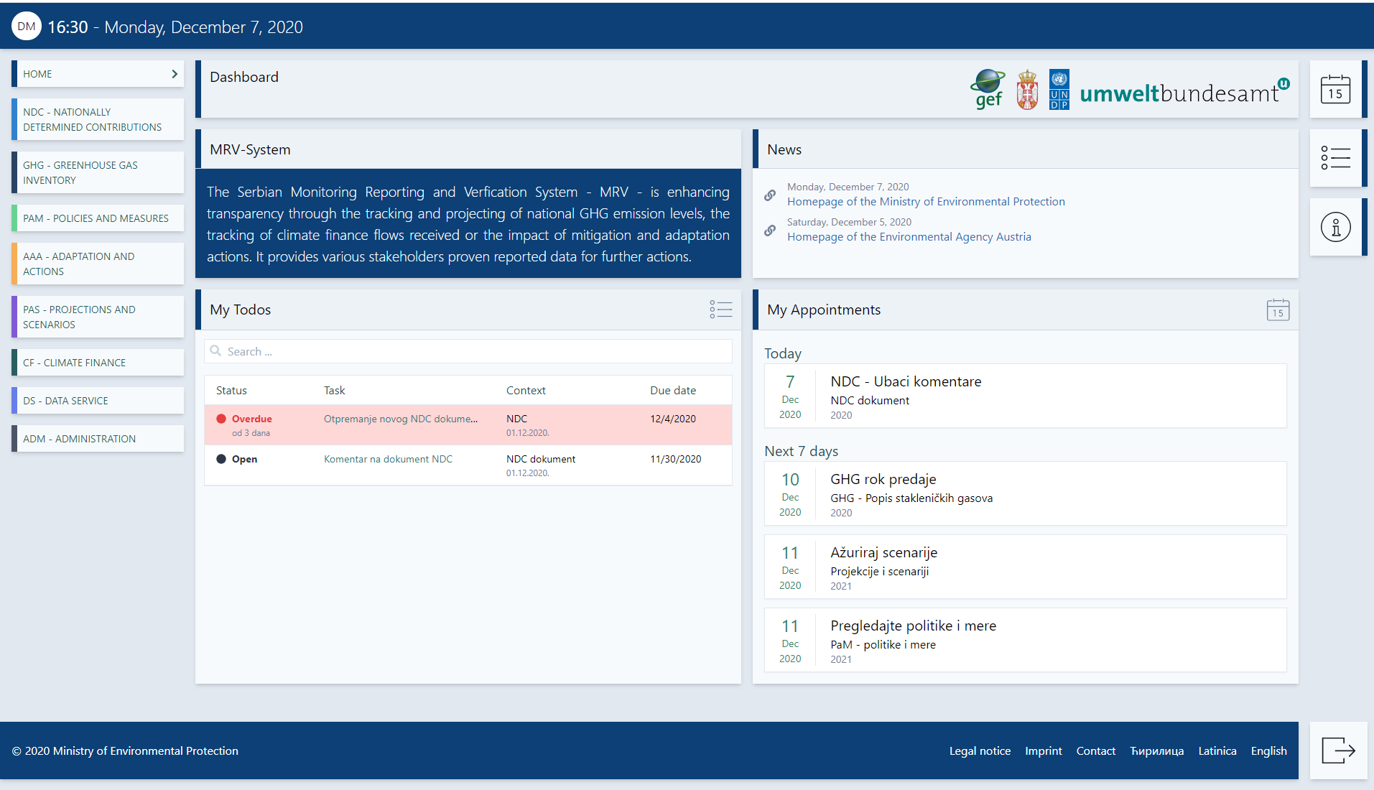

Figure 1: Landing page for the MRV IT system and its components – NDC, GHG inventory, PAMs, Adaptation action, Projections, Climate finance and data service.

The landing page provides the users of the system an overview of the granted modules on the left side and an overview of todos and appointments each user can set in the system.

To get an idea how a module could look like the NDC and GHG module have been mocked up as they could look at the end of the project. The rest of modules will be mocked as soon the conceptual framework has been agreed on each of the modules.

## NDC - Nationally Determined Contributions - Module

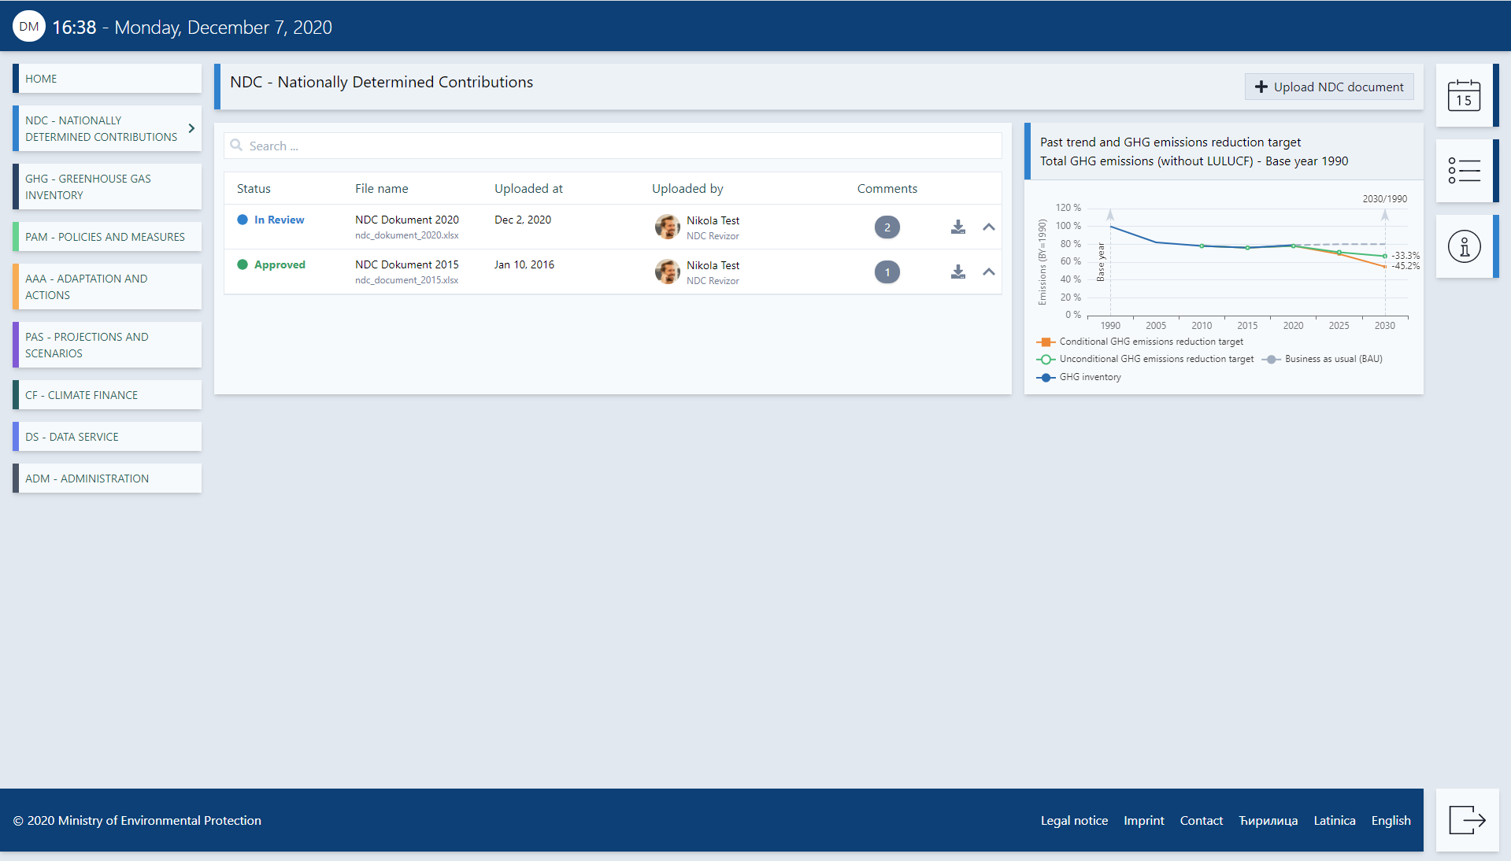

## GHG - Greenhouse Gas Inventory – Module

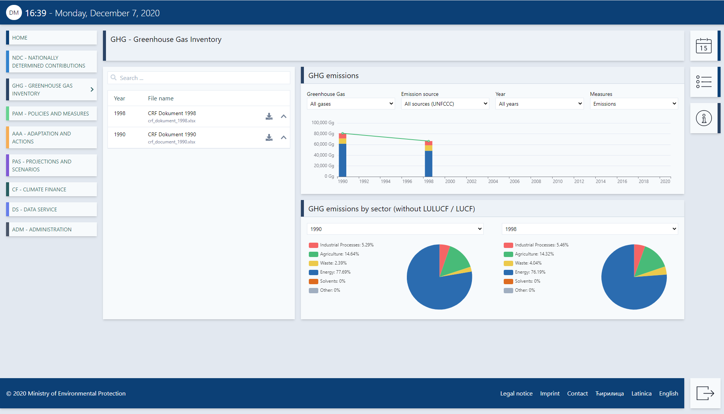

## PaM - Policies and Measures - Module

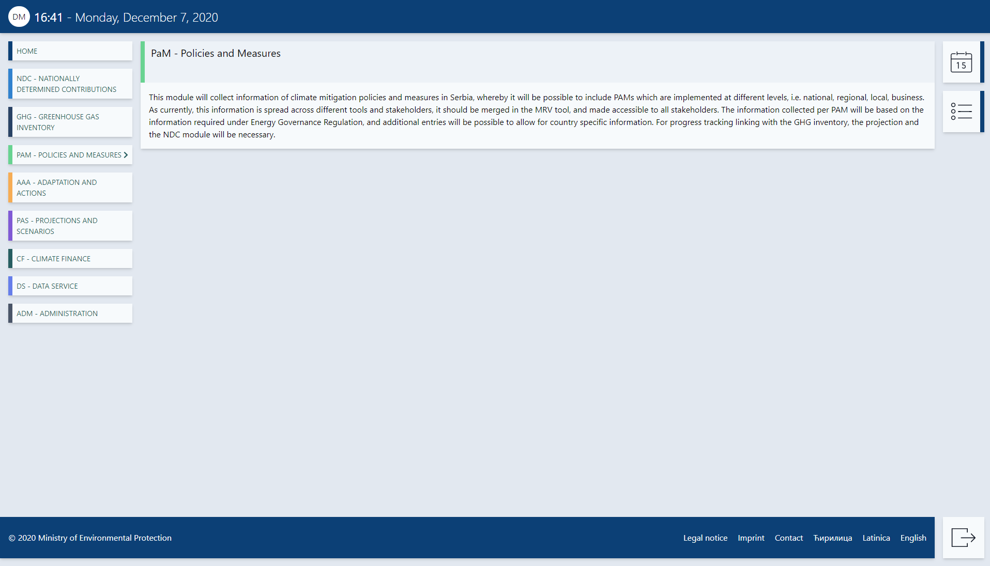

## AaA - Adaptation and Actions – Module

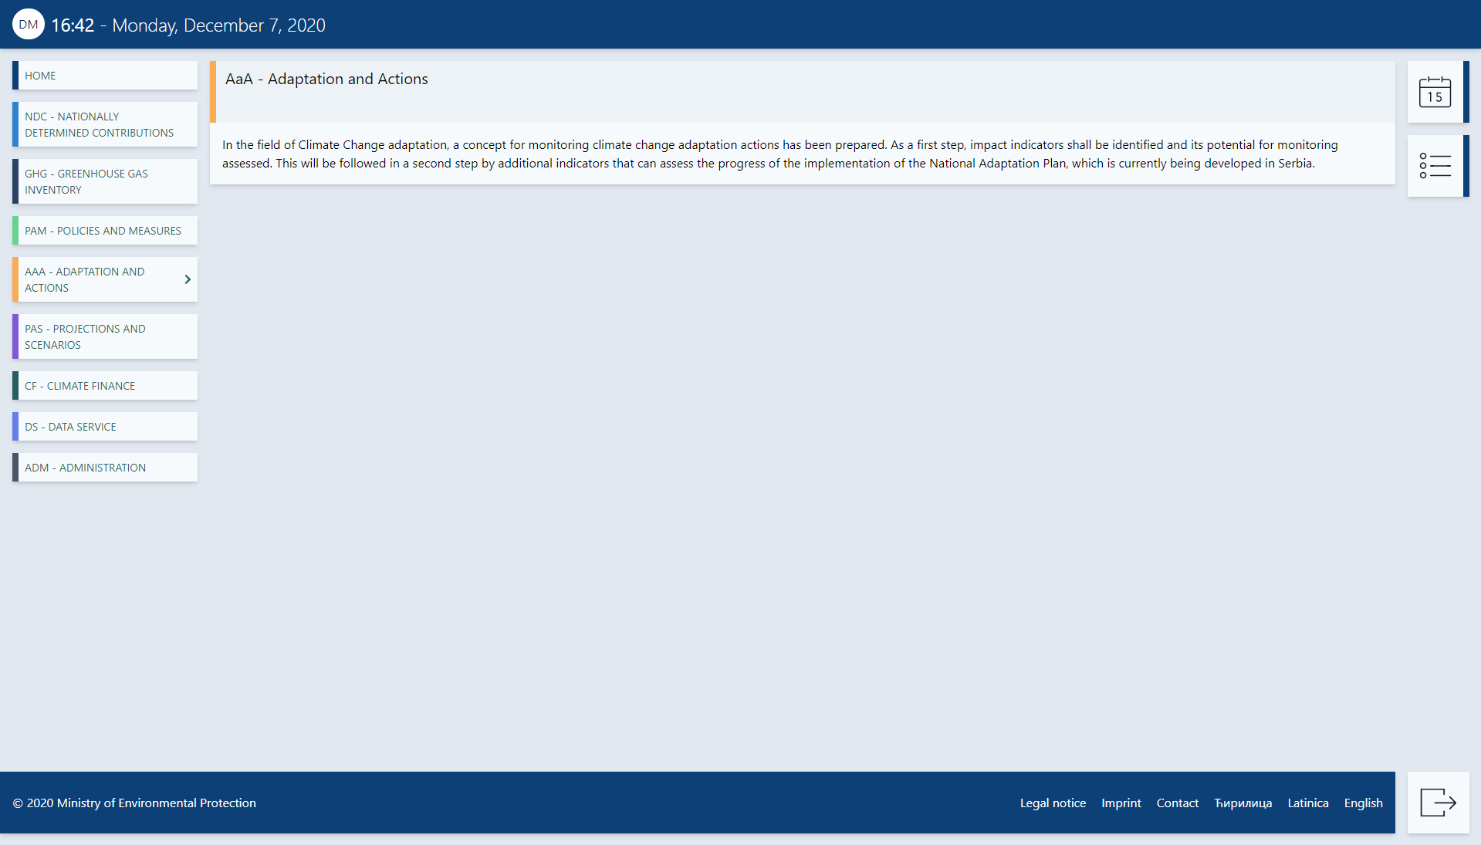

## PaS - Projections and Scenarios – Module

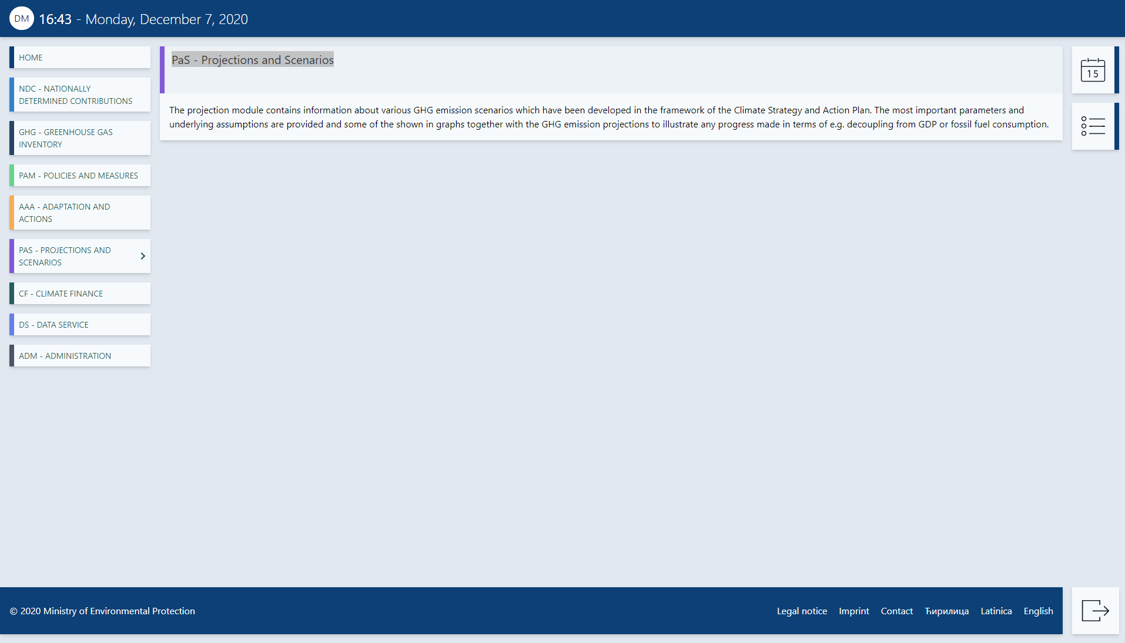

## CF - Climate Finance – Module

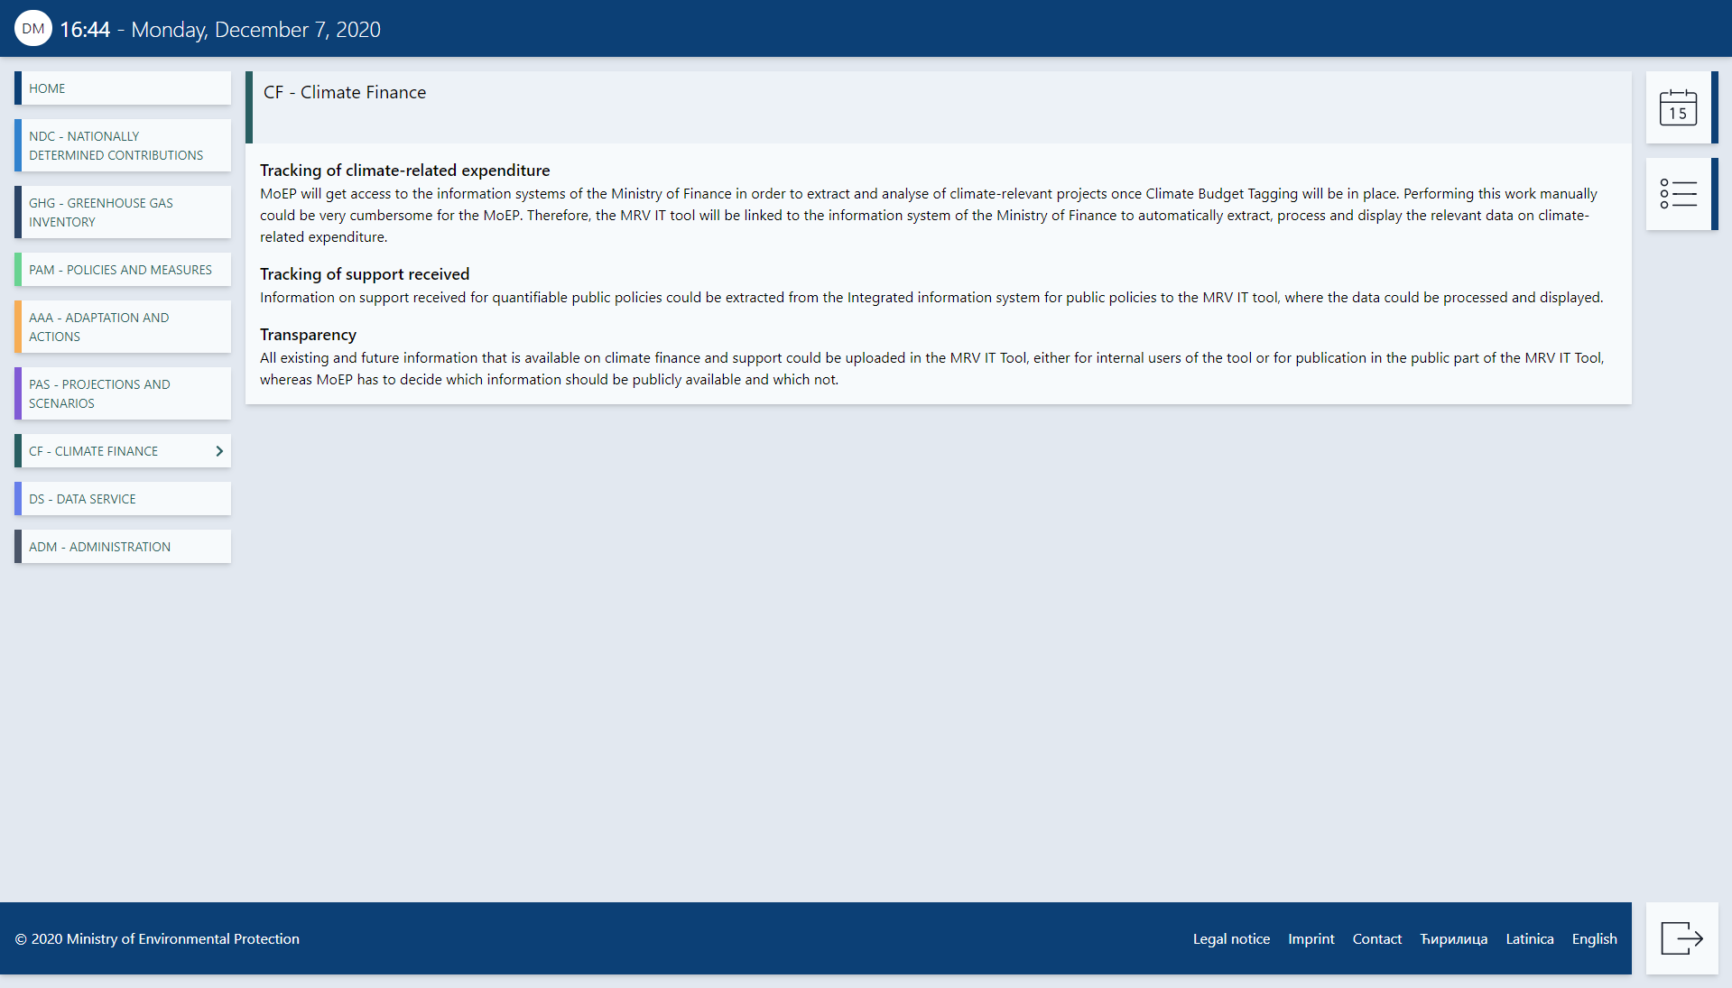

## DS - Data service – Module

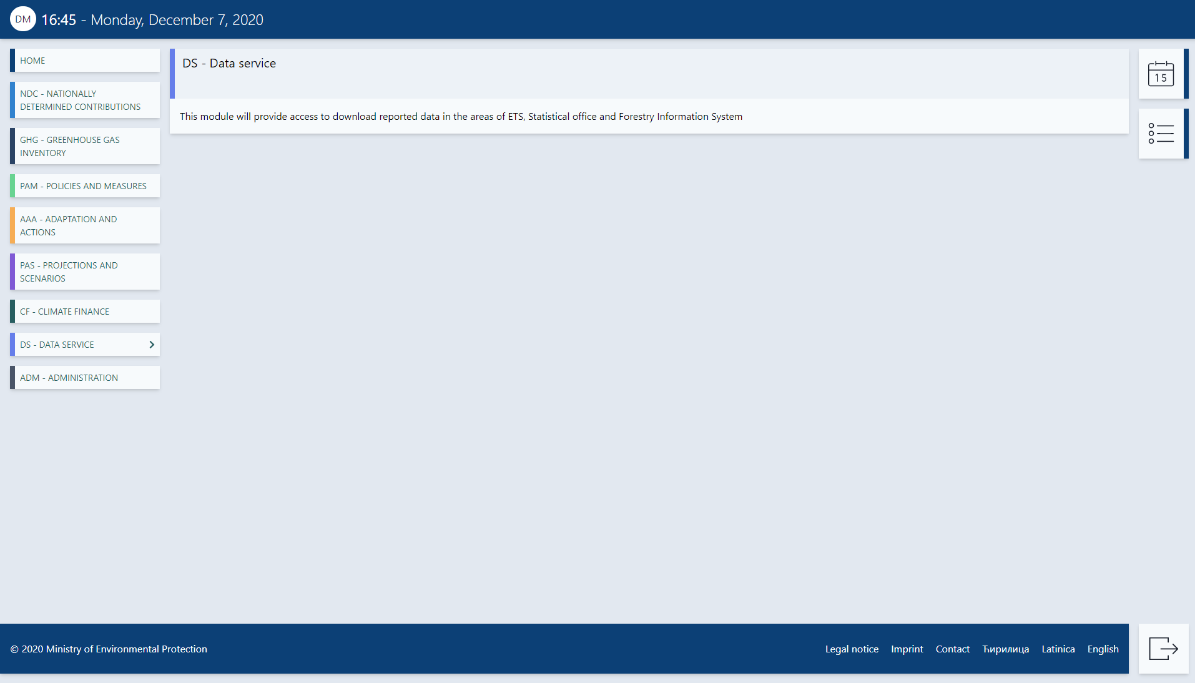

## Administration – Module

