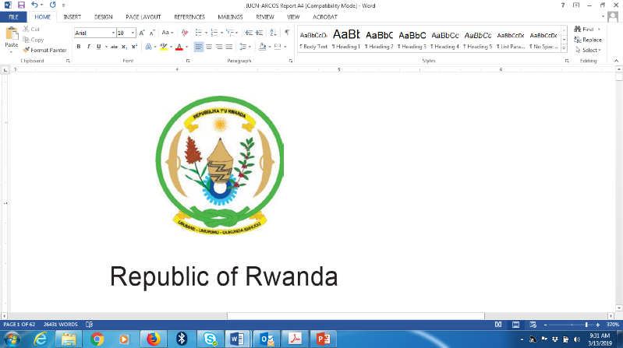
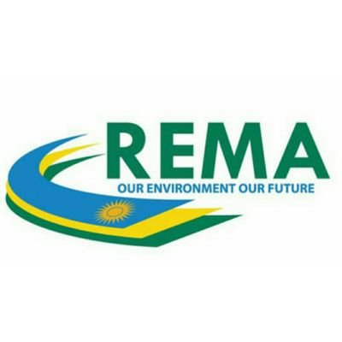



STRENGTHENING CAPACITY OF INSTITUTIONS IN RWANDA TO IMPLEMENT THE TRANSPARENCY REQUIREMENTS OF THE PARIS AGREEMENT

VIRTUAL INCEPTION WORKSHOP HELD ON CISCO Webex
10th September 2020, 14.00 -16.00

INCEPTION WORKSHOP REPORT

Table of Contents
1. Overview OF THE PROJECT 1
2. objective of the workshop 2
3. Workshop proceeding 2
A. Opening remarks 2
B. Presentation 1: Global Environment Facility (GEF) Standard Operating modalities, CIGEF Agency monitoring and reporting requirement 3
C. Presentation 2: Overview of CBIT Rwanda project and The Project’s Workplan 4
A. Key feedback from stakeholders 6
5. Summary of workshop and closing remarks 6
ANNEXES 7
ANNEX 1: Stakeholder Engagement Plan (SEP) 7
ANNEX 2: CBIT Rwanda Project Risk Assessment and Mitigation measures 12
ANNEX 3: List of Participants 13
ANNEX 4: CBIT Rwanda Project Steering Committee (PSC) Members 14

- Overview OF THE PROJECT
Rwanda as a Party to the United Nations Framework Convention on Climate Change (UNFCCC) and signatory of Paris Agreement is committed to join efforts with global community to combat climate change. Article 13 of the Paris Agreement establishes an Enhanced Transparency Framework (ETF) designed to build trust and confidence that all countries are contributing their share to the global effort and states that “Support shall also be provided for the building of transparency-related capacity of developing country Parties on a continuous basis”. For this reason, the Capacity-Building Initiative for Transparency (CBIT) was created, and the Global Environment Facility (GEF) was mandated to operationalize it and support developing countries to prepare and meet the enhanced transparency requirements for Paris Agreement.
Rwanda is among countries in Africa to benefit from the Capacity Building Initiative for Transparency fund by the GEF through Conservation International (CIGEF) as the Implementing Agency (IA) and the Rwanda Environment Management Authority (REMA) as the Executing Agency (EA).
The objective of the Rwanda CBIT Project is “To strengthen the capacity of Institutions in Rwanda to fulfil the Transparency Requirements of the Paris Agreement”. The project consists of three (3) components, namely:
- Strengthening National GHG Inventory System,
- Targeted capacity building of key stakeholders to collect, process and feed data into the GHG emissions inventory system; and
- Establishment of an integrated Platform for Data Sharing and informing Policy Making.

REMA organized an inception workshop for relevant stakeholders to introduce the CBIT Project and ensure continued stakeholder involvement throughout project implementation. The inception meeting took place on 10th, September 2020 from 14h00-16h00 pm (Kigali Time); and was convened virtually on Webex in respect and alignment with Government of Rwanda guidelines and measures to curb the spread of COVID 19 pandemic.

objective of the workshop
The overall objective of the Inception workshop was to introduce the project to the participants and enhance stakeholders’ understanding of the project objectives. The specific objectives are outlined below:

- To inform participants on the project scope, objectives, and activities.
- To inform participants on the overall project work plan including project results work plan, project risks management work plan and others.
- To discuss the project strategy to implement project activities.
- To introduce participants to CIGEF operational and programmatic guidelines for the CBIT project.

- Workshop proceeding
The workshop was attended by about 24 participants (25% Female and 75% Male) from Nationally Determined Contributions (NDC) sector-based institutions, Ministries, Academia, and the Private sector. These include The Ministry of Environment, The Ministry of Finance and Economic Planning (MINECOFIN), The Ministry of Infrastructure (MININFRA), The Rwanda Green Fund, The Rwanda Energy Group – Energy Utility Corporation Limited, The University of Rwanda – College of Science and Technology, The Rwanda Mines, Petroleum and Gas Board, among others. The list of participants is provided in Annex 3.

Opening remarks
The inception meeting was officiated by the Director of Climate Change and International Obligations, Mr. Herman Hakuzimana, on behalf of the Director-General of REMA. In his remarks, he acknowledged the presence of participants and thanked them for honouring the invite to the CBIT inception meeting. He highlighted that Article 13 of the Paris Agreement establishes an Enhanced Transparency Framework (ETF) designed to build trust and confidence that all countries are contributing their share to the global effort to keep global temperature rise well below 2ºC. Under this Enhanced Transparency Framework (ETF), Parties to the UNFCCC and Paris Agreement are required to regularly report GHG emissions information, Information to track progress made in implementing and achieving its NDC, and information on financial, technology, and capacity building provided, mobilized, needed and received.

Senior Director at the Africa Field Division Conservation International, Dr. Peter Alele addressed participants and thanked them for their continued contribution right from the stakeholder consultations of the PPG phase to the kickoff of CBIT project activities. He highlighted the cooperation CI has with various partners in Rwanda in the implementation of its priority areas including work on agriculture, coffee, Payment for Ecosystem Services (PES), and now capacity building.

In preparation for the implementation of these transparency requirements post-2020, the CBIT Rwanda project aims to support national institutions in Rwanda in building their capacity to fulfill reporting requirements, NDC tracking, and other transparency requirements of the Paris Agreement.

Presentation 1: Global Environment Facility (GEF) Standard Operating modalities, CIGEF Agency monitoring and reporting requirement
The CIGEF Standard Operating Modalities were presented by CIGEF Manager Africa, Ms. Charity Nalyanya. CIGEF oversees the execution of the project including Monitoring and Evaluation of the project; ensures the project complies with GEF operational modalities and technical backstopping of the project team. The CIGEF Agency is a GEF Implementing Agency that supports countries on various GEF funded projects including CBIT.

The GEF supports various conventions including The United Nations Framework Convention on Climate Change (UNFCCC) and its related agreements. The CBIT fund was set up to support countries to build their capacities to implement the transparency requirements of the Paris Agreement.

Regarding reporting to CIGEF, The Exectiing Agency (REMA) is expected to submit to CIGEF Quarterly technical and Financial progress reports and an annual Project Implementation Report. Other monitoring frameworks of the CIGEF Agency include site visits and desk reviews.

On the safeguards, she noted that the CI GEF has eleven safeguards, but this project only triggered three Safeguards outlined below. The Executing Agency is expected to implement, monitor, and report progress every quarter too:

- Gender Mainstreaming Policy – the purpose is to mitigate potentially adverse effects of the project on men and women and promote equality in participation and decision-making in consultative processes, access to natural resources and services, and project benefits
- Stakeholder Engagement Policy – it seeks and incorporates the knowledge and contributions of partner and stakeholders to ensure that CI/GEF work and project result in lasting and fundamental improvements for nature and human well-being.

- Accountability and Grievance Mechanisms Policy – it ensures the enforcement of CI’s Environmental and Social Management Framework (ESMF) policies and provides for the receipt of and timely response to the resolution of complaints from parties affected by its CI-GEF projects. She also highlighted the steps and processes involved in reporting and resolving stakeholder ‘s grievances, complaints, etc.
On GEF Visibility, she mentioned that GEF, REMA, CI logos must be appropriately displayed on any material generated by this project e.g., Knowledge Management Products, etc. Also, she stated that all electronic communication disseminating information should add the link to the GEF web site: https://www.thegef.org/project/strengthening-capacity-institutions-rwanda-implement-transparency-requirements-paris

Presentation 2: Overview of CBIT Rwanda project and The Project’s Workplan
The main objective of this project is to strengthen capacity of national institutions in Rwanda to implement transparency requirements of the Paris Agreement. The project activities will be executed through three components:
Component 1: Strengthening the National GHG Inventory system
Component 2: Targeted capacity building of key stakeholders to collect process and feed data into the GHG emissions inventory system (including on gender disaggregated data management for the GHG emissions inventory and MRV system.
Component 3: Integrated Platform for Data Sharing and Policy Making

The project activities are expected to be executed in 18 months.

Project Work Plans:
The CBIT project will be executed through REMA‘s Single Project Implementation Unit (SPIU). The Department of Climate Change and International Obligations (DCCIO) will work closely with the Project Management Unit towards successful completion of project activities. The CBIT project will be implemented through three components;
Component 1 contains 7 outputs;
Component 2 is covered in 3 outputs;
while component 3 is covered in 6 outputs.

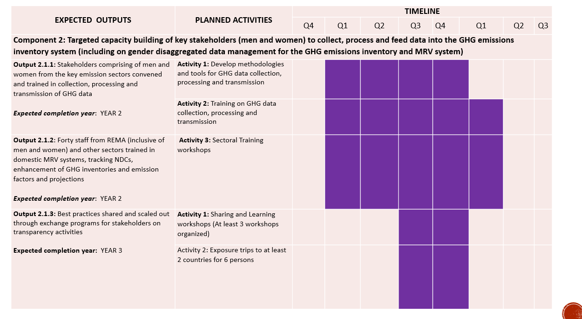
Figure 1: Presentation of Results Work Plan – Component 2
The overall work plan for the project also called project results work plan was presented. In this presentation, the outcome and outputs of the project were covered in depth. The Stakeholder engagement plan was also covered, and feedback was provided by participants.
Component 1 requires participation of stakeholder institutions through sectoral technical teams which will be formed at the beginning of the project and the GHG Working Group of the National Climate Change Committee (NCCC). Line Ministries and the Ministry of Environment will also be involved in cooperation arrangements between REMA and NDC sector institutions. Component 2 and 3 will heavily involve stakeholders at national and sub national levels through training workshops and knowledge sharing platforms on handling GHG related data and information.

- Way forward toward successful project implementation
The discussion focused on the project target areas which is strengthening Rwanda’s National Green House Gas Inventory (GHGI) system, nationwide capacity building and GHG data integration. The participants suggested that the project should help and assist the GHGI team in documenting and reporting the methodologies, dataset and emission factors used, to help future inventory teams to complete the next Greenhouse gases inventory.

The discussions indicated the role of local government in the implementation phase. As one of the GHG data sources is local government, and one of the project activities will be the capacity building, local government staff will be engaged according to the stakeholder engagement plan as detailed in Annex A.

Key feedback from stakeholders
- Consultants/experts recruited in this project must work closely with the national sector experts, from the first step to the validation process, to ensure the national experts benefit from every activity, this will help build the capacity of sectors to collect and report on their GHG data;
- Before conducting capacity building, capacity needs assessment is required to ensure that the key purpose of data collected at national and sub national level is understood by data providers.
- There were no major changes required to the project results work plan and stakeholder engagement plan. The participating institutions pledged to continue collaboration with REMA through technical teams and Project Steering Committee (PSC)

- Summary of workshop and closing remarks
Strengthening Capacity of Institutions in Rwanda to implement the Transparency Requirements of the Paris Agreement will help Rwanda to strengthen the National GHG Inventory system; build capacity of Rwanda’s key stakeholders to collect, process and feed data into the GHG emissions inventory system; and develop an integrated platform for GHG data sharing and policy making.

In his closing remarks, Mr. Hakuzimana (The Director of climate change and international obligations) and Dr Alele (The Senior Director, Conservation International, Africa Field Division) thanked the participants for their active participation in the meeting; contribution in the discussions and they looking forward to collaboration and successful implementation of this project.

ANNEXES

ANNEX 1: Stakeholder Engagement Plan (SEP)
Stakeholder  Name and Function  Name of the key stakeholder, and their main purpose/function |  |  | Stakeholder’s Interest  What are the stakeholder’s main interests in and concerns about the project | Impact of Project on Stakeholder  How will the stakeholder be affected (both positively and negatively) by the project? | Influence of Stakeholder  How can the stakeholder affect the project? Can they hinder or contribute to the success of the project? | Risk Management  (Is this a low, medium or high-risk stakeholder? And how would you manage medium/high risk stakeholders)
Ministry of Environment (MoE) | Public | Established to ensure the conservation, protection and development of the environment. It also ensures the safeguard of green and climate resilience for growth of the economy.  Responsible for implementing the Results Based Management (RBM) Policy | Policy guidance and beneficiary | Built technical and institutional capacity | - PSC Member  - Technical guidance Training beneficiary | Low
Rwanda Environment Management Authority (REMA) | Public | To facilitate the coordination and oversight for implementation of national environmental policy.  Rwanda’s Designated National Authority (DNA) and climate change focal point to the UNFCCC. | Lead executing agency and beneficiary | Built technical and institutional capacity | - PSC Member  - Project host institution  - Technical expertise  - Participate at UNFCCC and CBIT events  - Trainings | Low
Rwanda Meteorology Agency |  | To provide accurate, timely weather and climate information and products for the general welfare of the peoples of Rwanda | Participant and Beneficiary | Built technical and institutional capacity | - Technical Team member  - Trainings | Low
The Association pour la Conservation de la Nature au Rwanda (ACNR) | Public | To promote biodiversity conservation through participatory and sustainable management of natural resources in Rwanda. | Beneficiary | Built technical and institutional capacity | - Trainings on use of integrated data platform | Low
CROSS CUTTING
Fund for Environment and Climate Change (FONERWA) | Public sector | Rwanda's Green Fund for environment and climate change projects. | Beneficiary | Built technical and institutional capacity | Establishing the integrated data platform | Low
Ministry of Local Government | Public sector | Coordination of good governance and high quality territorial administration programs that promote economic, social and political development throughout the nation | Beneficiary | Built technical and institutional capacity | Training on data collection, processing and transmission | Low
Rwanda Resource Efficiency & Cleaner Production Centre – waste and energy | Public sector | Mandate is to build capacities of industries and Small Medium Enterprises for waste minimization and efficient utilization of resources | Beneficiary | Built technical and institutional capacity | All technical trainings | Low
University of Rwanda- College of Science and Technology | Academia | Lead - Energy, IPPU and Waste Sector Working Groups at REMA | Beneficiary | Built technical and institutional capacity | Member Technical Team  Trainings | Low
National Institute of Statistics of Rwanda (NISR)- Environmental Statistics Department | Public Sector | Primary data producer and produces mandatory statistics such as GDP and population statistics, special purpose-statistics such as the Demographic and Health Survey (DHS), and Household Living Conditions Survey.  Also conducts specific joint surveys such as Agriculture Survey, in partnership with the relevant institutions. | Beneficiary | Built technical and institutional capacity | - PSC member  - Data management methodologies development | Low
Rwanda Revenue Authority |  | Tax assessment, collection and accounting | Beneficiary | Built technical and institutional capacity | Training on data integration | Low
Rwanda Development Board (RDB) |  | Implementing the National Data Centre | Beneficiary | Built technical and institutional capacity | Training on data integration | Low
Ministry of Education (MINEDUC) |  | Hosts the Climate observatory Centre | Beneficiary | Built technical and institutional capacity | - PSC member  - Expert input | Low
Rwanda Biomedical Centre |  | Responsible for medical waste management | Beneficiary | Built technical and institutional capacity | Technical Team member | Low
Ministry of Gender and Family Protection | Public | To plan and coordinate implementation of the National Gender Policy | Beneficiary | Built technical and institutional capacity | - Co-opted to the PSC  - Training on data management | Low
National Climate Change Committee | Public | Coordinating the GHG Working Group | Beneficiary | Built technical and institutional capacity | - Sub-grantee  - PSC member | Low
Rwanda Utilities Regulatory Authority (RURA) | Public | Regulate selected public Utilities in the areas of telecommunications electricity, water, removal of waste products from residential or business premises, extraction and distribution of gas and transport of goods and persons. | Beneficiary | Built technical and institutional capacity | - Technical Team member  - Trainings | Low
Private Sector Federation | Private sector | Promoting and representing the interests of the Rwandan business community | Beneficiary | Built technical and institutional capacity | Trainings | Low
RECOR (Rwanda Environmental Conservation Organization) | NGO | Areas of focus include; climate change, biodiversity conservation, renewable energy, education for sustainable development, forestry, agroforestry, water, hygiene and sanitation. | Beneficiary | Built technical and institutional capacity | Trainings | Low
World Conservation Society (WCS)/Vital Signs | INGO | Ecosystems data supplier | Partner | Built technical and institutional capacity | Technical expertise | Low
AGRICULTURE
Ministry of Agriculture and Animal Resources (MINAGRI) | Public | Policy oversight for agriculture sector | Partner | Built technical and institutional capacity | Technical Team member - AFOLU | Low
Rwanda Agriculture Board (RAB) | Public | Member AFOLU Working Group at REMA | Beneficiary | Built technical and institutional capacity | Technical Team member - AFOLU | Low
University of Rwanda- College of Agriculture, Animal Science and Veterinary Medicine | Academia | Lead – AFOLU Sector Working Group at REMA | Beneficiary | Built technical and institutional capacity | Member Technical Team | Low
TRANSPORT
Ministry of Infrastructure (MININFRA) | Public | Policy oversight | Beneficiary | Built technical and institutional capacity | PSC member | Low
Rwanda Transport Development Agency (RTDA) | Public | Responsible of promoting the transport services for persons and goods in the country | Beneficiary | Built technical and institutional capacity | Technical Team member - Energy | Low
ENERGY
Energy Development Corporate Limited (EDCL) | Public | Member – Energy Sector Working Group at REMA | Beneficiary | Built technical and institutional capacity | Technical Team member - Energy | Low
Rwanda Energy Group | Public company | Incorporated to expand, maintain and operate the energy infrastructure in the Country through its two subsidiaries the Energy Utility Corporation Limited (EUCL) and the Energy Development Corporation Limited (EDCL). | Expertise | Built technical and institutional capacity | Energy expertise | Low
Rwanda Mines, Petroleum and Gas Board | Public | Mandated to monitor and coordinate implementation of strategies related to mines, petroleum and gas; Conduct research & exploration in geology, mining and petroleum and disseminate the findings; Supervise and monitor private or public entities conducting mining, trade and value addition of mineral operations; and Assist government in valuing mining and quarry concessions. | Policy guidance and Expertise | Built technical and institutional capacity | Co-opt onto PSC and Technical Team meetings | Low
LAND USE
Rwanda Housing Authority (RHA) | Public | It was established in a bid to improve the quality of life of Rwandans through planning, organizing and spearheading rural settlement, urban settlement, public building construction, affordable housing; management of public office space and Government Assets; and regulation of the construction industry. | Beneficiary | Built technical and institutional capacity | Technical Team member- AFOLU | Low
Rwanda Water and Forestry Authority (RWFA) | Public | Member – AFOLU Sector Working Group at REMA |  | Built technical and institutional capacity | Technical Team member - AFOLU | Low
Rwanda Land Use and Management Authority | Public | Responsible for putting in place and operationalizing an efficient system of land administration, use and land management that secures land ownership in the country |  | Built technical and institutional capacity | Technical Team member - AFOLU | Low
INDUSTRY
Ministry of Trade, Industry and East African Community Affairs (MINEACOM) | Public | Policy guidance | Beneficiary | Built technical and institutional capacity | PSC member | Low
National Industrial Research & Development Agency (NIRDA) | Public | Mandated with a mission to enable a generation of industrial innovators to become competitive through technology monitoring, acquisition, development and transfer & applied research. | Beneficiary | Built technical and institutional capacity | Technical Team member - IPPU | Low
WASTE
City of Kigali (CoK)–Directorate of Health & Environment Unit | Public | Member – Waste Sector Working Group at REMA | Beneficiary | Built technical and institutional capacity | Technical Team member | Low
Company for Environment Protection and Development (COPED) | Private sector | Specialized in waste management and recycling  Member – Waste Sector Working Group at REMA | Beneficiary | Built technical and institutional capacity | Technical Team member | Low
Rwanda Water and Sanitation Corporation (WASAC) | Public  sector | Entity setup to manage the water and sanitation services in Rwanda | Beneficiary |  | Technical Team member | Low

ANNEX 2: CBIT Rwanda Project Risk Assessment and Mitigation measures
Risks | Rating  (Low, Medium, High) | Risk Mitigation Measures
- Political risks associated with changes in governance, key personnel within government agencies, security, and/or government decisions | Low | - Rwanda is one of the most stable countries in the region. Mitigation measures are limited for insecurity but since the country has enjoyed relative stability for many years now, major political turmoil is unlikely.  - Continuous awareness and dialogue with stakeholders will also ensure minimal impacts of any political changes on the project.  - Signing of MoUs between the various government institutions will also ensure maintenance of the status quo even after changes occur within these institutions.
- Climate Change: Rwanda, as with many developing countries suffer greatly from effects of climate change with frequent floods, storms, droughts affecting infrastructure and disrupting services | Low | - Raising awareness on risks of climate change on the project  - Development of climate risk mitigation strategies
- Inadequate participation of all stakeholders and partners, poor cooperation between participating institutions, and stakeholders remain engaged and supportive of the program | Medium | - Continuous engagement of institutions, regular reporting, monitoring of progress, and acknowledgement of efforts and achievements by each institution  - Participating institutions will be actively involved from the beginning in design, implementation and management decisions  - Roles and responsibilities will be explicit and participants allowed to transparently implement while sharing regular updates on progress  - Communication plans and stakeholder requirements and expected outputs will be fully developed  - Regular progress and monitoring meetings will be held
- Inadequate equipment for MRV | Medium | - The CBIT project will provide MRV equipment to REMA and sector hubs
- Inadequate long-term domestic capacity for data management, and management of the GHG emissions inventory and the MRV system persists | Low | - Vital Signs programme has expertise in integrating data from several sources to provide decision support. In this project, Vital Signs will contribute to data integration and strengthening of local capacity, and will ensure that a crop of technical individuals remain after the project to manage the inventory and MRV systems  - Selection of trainees (men and women) from several key institutions and the hub will ensure that capacity is spread to create options and reduce the risk of limiting access to the capacity within one institution.  - Training of Trainers (ToTs) will be undertaken to ensure project sustainability
- Corona Virus Pandemic | High | - Regular budget revision in respones to government regulations to combat COVID-19 particularly with capacity building activities/meetings under component 2  - Revise the workplan to identify activities that can be undertaken remotely  - Follow and abide by the Government regulations and measures to combat COVID-19 pandemic  - Create awareness of COVID-19 pandemic and provide hygiene materials to project communities e.g, hand sanitizers, face masks, gloves etc

ANNEX 3: List of Participants
A total of 24 stakeholders participated in the inception workshop (25% Female and 75% Male).
No. | Name | Institution | Gender | Contact
1 | Faustin MUNYAZIKWIYE | Rwanda Environment Management Authority | Male | fmunyazikwiye@rema.gov.rw
2 | Alex MUGABO | Rwanda Environment Management Authority | Male | amugabo@rema.gov.rw
3 | Peter ALELE | Conservation International | Male | palele@conservation.org
4 | Charity NALYANYA | Conservation International | Female | cnalyanya@conservation.org
5 | Isabel INJETE | Conservation International | Female | iinjete@conservation.org
6 | Victor ESENDI | Conservation International | Male | vesendi@conservation.org
7 | Janet UMUGWANEZA | Rwanda Environment Management Authority | Female | jumugwaneza@rema.gov.rw
8 | Herman HAKUZIMANA | Rwanda Environment Management Authority | Male | hakuzimana@rema.gov.rw
9 | David UKWISHAKA | Rwanda Environment Management Authority | Male | dukwishaka@rema.gov.rw
10 | Apollinaire TWAHIRWA | Rwanda Environment Management Authority | Male | atwahirwa@rema.gov.rw
11 | Pearl NKUSI | Rwanda Environment Management Authority | Female | pnkusi@rema.gov.rw
12 | Patrick UMUHOZA | Rwanda Environment Management Authority | Male | pumuhoza@rema.gov.rw
13 | Fred HAVUGIYAREMYE | Ministry of Trade and Industry | Male | fhavugiyaremye@minicom.gov.rw
14 | Theophile DUSENGIMANA | Ministry of Environment | Male | tdusengimana@environment.gov.rw
15 | Dismas BAKUNDUKIZE | Rwanda Forestry Authority | Male | bakudismas@gmail.com
16 | Martin MUSONERA | Energy Development Corporation Limited (EDCL) | Male | mmusonera@edcl.reg.rw
17 | Cyprien NDAYISABA | Rwanda Transport Development Agency (RTDA) | Male | cyprien.ndayisaba@rtda.gov.rw
18 | Jean Pierre NGENDABANGA | National Industrial Research and Development Agency (NIRDA) | Male | jpierre.ngendabanga@nirda.gov.rw
19 | Aminadab TUYISENGE | Rwanda Meteorology Agency (Meteo Rwanda) | Male | a.tiyusenge@meteorwanda.gov.rw
20 | Dancille MUKAKAMARI | ARECO Rwanda Nziza | Female | mukakamari@yahoo.fr
21 | Sylvie KAWERA | Rwanda Green Fund (FONERWA) | Female | s.kawera@fonerwa.org
22 | Emmanuel BYIRINGIRO | Rwanda Mines, Petroleum and Gas Board | Male | emmanuel.byiringiro@rmb.gov.rw
23 | Frank RUTEHENDA | Ministry of Finance and Economic Planning | Male | frank.rutehenda@minecofin.gov.rw
24 | Jean Claude INGABIRE | Ministry of Local Government | Male | claude.ingabire@minaloc.gov.rw

ANNEX 4: CBIT Rwanda Project Steering Committee (PSC) Members
The CBIT Rwanda PSC has 14 members (4 Women and 10 Men)
No. | Name | Position | Institution | Gender | Contact
1 | Juliet KABERA | Chair | Rwanda Environment Management Authority | Female | jkabera@rema.gov.rw
2 | Victor ESENDI | Co-Chair | Conservation International | Male | vesendi@conservation.org
3 | Pearl NKUSI | Secretariat | Rwanda Environment Management Authority | Female | pnkusi@rema.gov.rw
4 | Elvis Blaise NKUNDANYIRAZO | Secretariat | Rwanda Environment Management Authority | Male
5 | Theophile DUSENGIMANA | Member | Ministry of Environment | Male | tdusengimana@environment.gov.rw
6 | Dismas BAKUNDUKIZE | Member | Rwanda Forestry Authority | Male | bakudismas@gmail.com
7 | Martin MUSONERA | Member | Energy Development Corporation Limited (EDCL) | Male | mmusonera@edcl.reg.rw
8 | Cyprien NDAYISABA | Member | Rwanda Transport Development Agency (RTDA) | Male | cyprien.ndayisaba@rtda.gov.rw
9 | Dr. Egide KALISA | Member | University of Rwanda – College of Science and Technology | Male | kalisa.egide@gmail.com
10 | Donatha NIBAGIRWE | Member | RCCDN - Rwanda Climate Change and Development Network | Female | nibagwired@gmail.com
11 | Pamela RUZIGANA | Member | Rwanda Water Resources Board | Female | Pamela.ruzigana@rwb.rw
12 | Dr. Kanisius Patrick MUGUNGA | Member | University of Rwanda – College of Agriculture, Animal Sciences and Veterinary Medicine | Male | mugungacp@gmail.com
13 | Herman HAKUZIMANA | Member | Rwanda Environment Management Authority | Male | hakuzimana@rema.gov.rw
14 | Nsabukunze Felicien | Member | Rwanda Meteorology Agency | Male | f.nsabukunze@meteorwanda.gov.rw
15 | Representative of MINECOFIN ( To be nominated)

CBIT Rwanda GEFSEC Link: https://www.thegef.org/project/strengthening-capacity-institutions-rwanda-implement-transparency-requirements-paris

